Acids & Bases weblab
Name and date submitted (3 pts):
Create space in the Word document below, and write or type your answers. Turn in your completed work by the due date.
Go to https://phet.colorado.edu/ and find the “pH Scale” simulation. At the time of writing, it was located here https://phet.colorado.edu/en/simulations/ph-scale

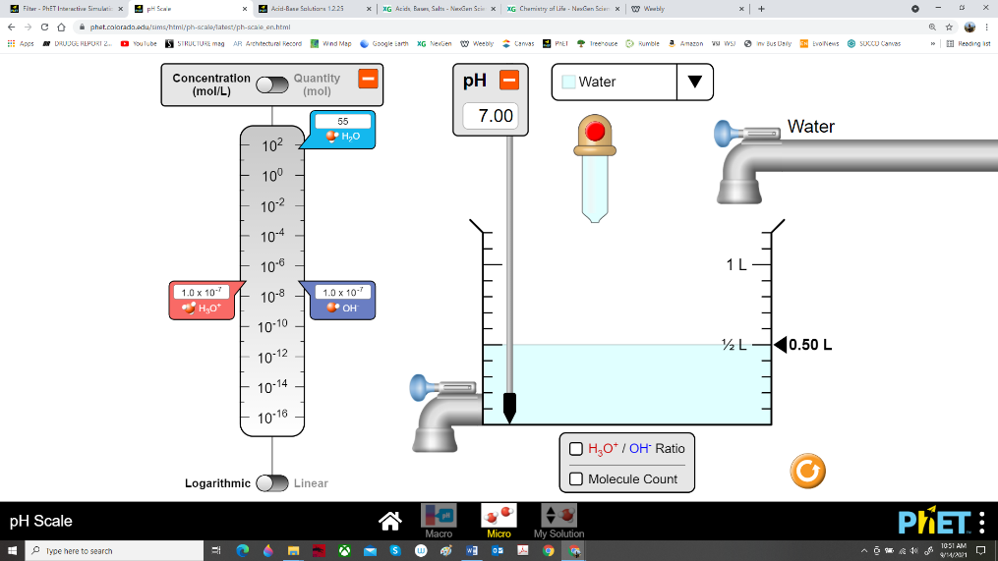
Select the “Micro” option.

Check the boxes “H₃O/OH Ratio” and “Particle Count”. Add water to the 1.00 L mark.
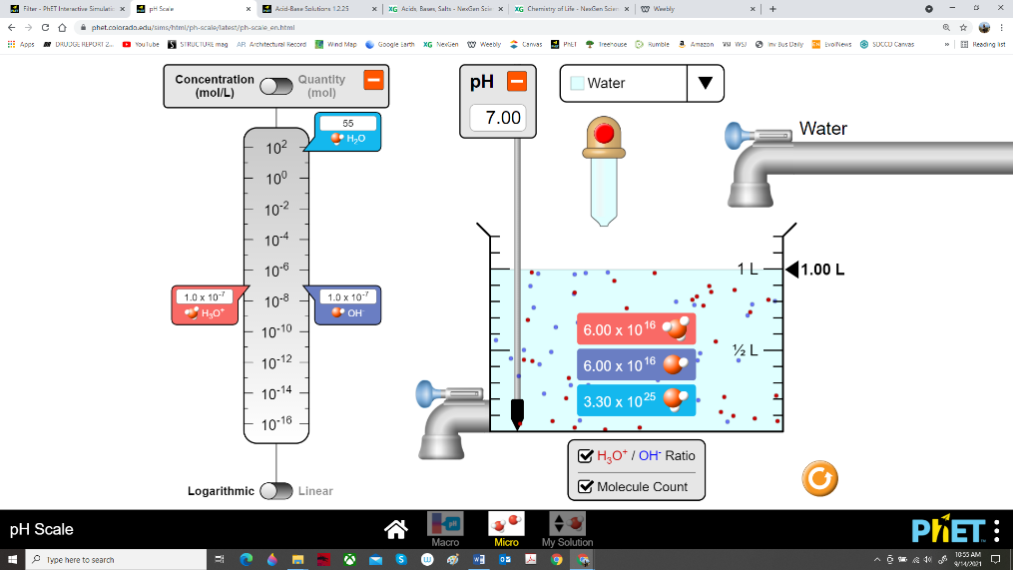

Substance 1: Water
EVERYONE ANSWER:
- What is the pH of pure water?

- Does this make it an acid, a base, or neutral?

- State the concentration in mol/L of the hydronium ion (H₃O⁺)

- State the concentration in mol/L of the hydroxide ion (OH⁻)

- Drain the water down to 0.5 L. Did the pH change, or stay the same?

- Water as a solvent: During lab, Sue places sucrose (table sugar) in a glass beaker, adds water, and stirs. As the table sugar disappears, she loudly proclaims that she has chemically broken down the sucrose into fructose and glucose. Is Sue’s chemical analysis correct? EXPLAIN, using correct chemistry terms!

ALL CHEMISTRY & AP BIOLOGY ONLY:
- How many molecules of water are present in 1 L?

- How many hydronium ions (H₃O⁺) are present in 1 L?

- How many hydroxide ions (OH⁻) are present in 1 L?

AP CHEMISTRY ONLY:
- The app says that there’s 55 mols of water in 1L. Prove it! Demonstrate it using correct chemistry formula(s) and conversions!

- The app gives values for the pH, and the concentration in mols/L of hydronium ions (H₃O⁺). Prove it! Demonstrate the connection between these values using correct chemistry formula(s) and conversions!

Substance 2: Blood
Now choose ‘blood’ from the dropdown menu and then add more blood to the 1L mark.
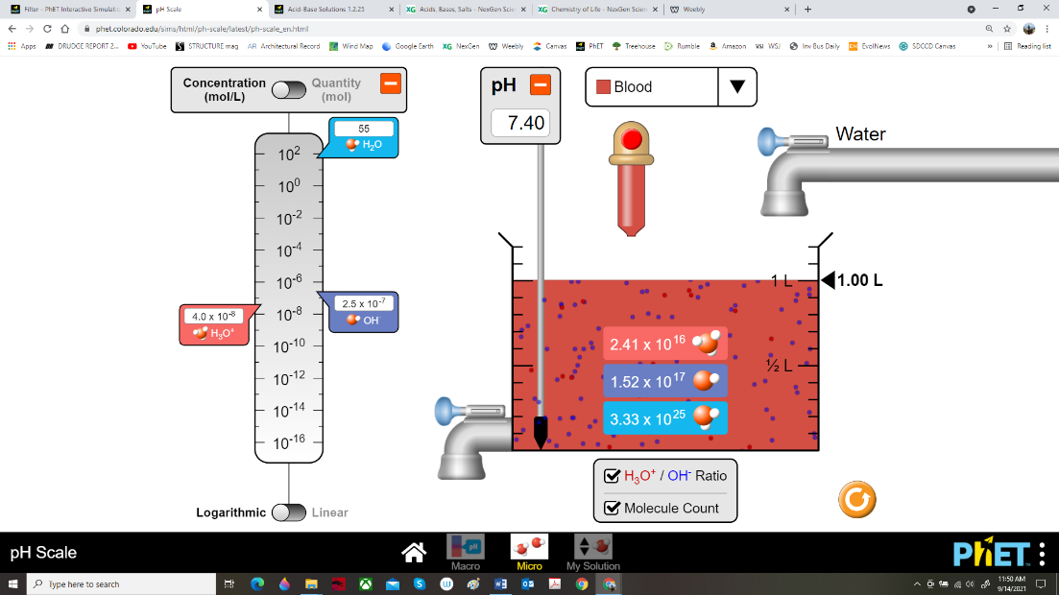

EVERYONE ANSWER:
- What is the pH of blood?

- Does this make it an acid, a base, or neutral?

- State the concentration in mol/L of the hydronium ion (H₃O⁺) in blood

- State the concentration in mol/L of the hydroxide ion (OH⁻) in blood

- Drain the blood down to 0.5 L. Then add water back up to 1.0 L (i.e. dilute the blood 50/50). Is the diluted blood mixture more acidic or less acidic than pure blood?

ANATOMY & PHYSIOLOGY AND AP BIOLOGY ONLY:
- Blood pH disorders: A person whose blood pH has fallen below 7.35 is considered to be in “acidosis”. Acidosis has several symptoms. Do Internet research on this disorder and list 4-5 symptoms of acidosis. Number them!

AP BIOLOGY & AP CHEMISTRY ONLY: (start over with 1L of pure blood)
- How many molecules of water are present in 1 L of blood?

- How many hydronium ions (H₃O⁺) are present in 1 L of blood?

- How many hydroxide ions (OH⁻) are present in 1 L of blood?

- Explain how your blood is buffered with the carbonic acid/bicarbonate buffer system to maintain its pH. This may require Internet research. Take pride in your work; I’m looking for an ‘AP’ answer.

AP CHEMISTRY ONLY: (start over with 1L of pure blood)
- The app gives values for the pH of blood, and the concentration in mols/L of hydronium ions (H₃O⁺). Prove it! Demonstrate the connection between these values using correct chemistry formula(s) and conversions!

- Now return to the 1L of diluted blood (50/50 dilution with water). Explain why the pH went down. Don’t just say “duh because it’s watered down”! I want you to demonstrate the connection between 1) the new number of hydronium ions (H₃O⁺), 2) the new concentration in mols/L of hydronium ions (H₃O⁺), and 3) the new pH, using correct chemistry formula(s) and conversions!

Substance 3: Vomit (hydrochloric acid, HCl)
Now choose ‘vomit’ from the dropdown menu and then add more vomit to the 1L mark.
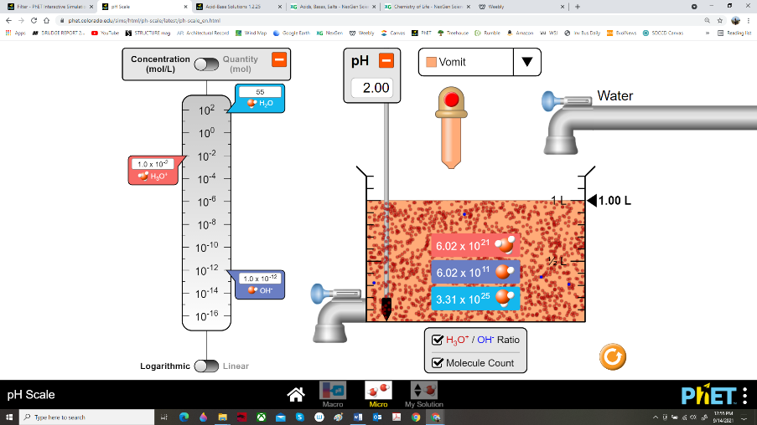

EVERYONE ANSWER:
- What is the pH of vomit?

- Does this make it an acid, a base, or neutral?

- State the concentration in mol/L of the hydronium ion (H₃O⁺) in vomit

- State the concentration in mol/L of the hydroxide ion (OH⁻) in vomit

- Drain the vomit down to 0.5 L. Then add water back up to 1.0 L (i.e. dilute the vomit 50/50). Is the diluted vomit mixture more acidic or less acidic than pure vomit?

ANATOMY & PHYSIOLOGY and AP BIOLOGY ONLY:
- Tony loves Italian food. One evening he ordered salad, a large plate of spaghetti, garlic bread, and wine. For dessert, he consumed “death by chocolate” cake and a cup of coffee. He topped off his evening with a cigarette and brandy. He returned home and, while lying on his couch watching TV, he experienced sharp pain in his chest. He called 911 because he was certain he was having a heart attack. Tony’s heart was fine, but he needs to watch his diet. What happened to Tony? Be specific and use correct Anatomy terms! Explain what happened. Use chemistry and anatomy terms. Draw sketches if you want. Take pride in your work!

AP BIOLOGY & AP CHEMISTRY ONLY: (start over with 1L of pure vomit)
- How many molecules of water are present in 1 L of vomit?

- How many hydronium ions (H₃O⁺) are present in 1 L of vomit?

- How many hydroxide ions (OH⁻) are present in 1 L of vomit?

- Biochemistry question: Explain the function of the enzyme “pepsin” and the function of hydrochloric acid (HCl) in stomach digestion. AP Biology students focus your answer more on the biology aspect; AP Chem students focus your answer more on the chemistry aspect.

AP CHEMISTRY ONLY: (start over with 1L of pure blood)
- Start with 1L of pure vomit (hydrochloric acid). Drain down to 0.1L, and top it up to 1L with pure water (dilute the stomach acid 10:1 in other words). Note the change in pH. Now do it again – drain the 10:1 acid down to 0.1L, and top that up to 1L again with pure water. Note the pH change again. Questions:
  - What is going on with pH? What does 1 pH unit represent, in terms of dilution?

  - If you started with 1L of acid having a pH of 2.0, how many L of water would you need to add to bring the pH all the way up to 5.0? Show your work!

