Separation of the Components of a Ternary Mixture

Accompanying lab videos:
https://www.youtube.com/watch?v=yUWmLCK-hOc&feature=youtu.be Exp 3, part 1
https://www.youtube.com/watch?v=E-A-mZlBENI&feature=youtu.be Exp 3, part 2
https://www.youtube.com/watch?v=4_S8A8MBHbk&feature=youtu.be Exp 3, part 4

Pure substances are characterized by various types of properties. Physical properties are those properties that can be determined without changing the identity of the substance. Examples of physical properties are boiling point, melting point and solubility.
Chemical properties of substances are their behavior with other substances. These can
only be determined by sacrificing a small amount of substance and reacting it with something else. Examples of chemical properties include flammability and reactivities with various substances.
Substances occur in many forms. Basically, however, there are two major categories. A
pure substance has only one set of physical and chemical properties. If it is made up of only one component and cannot be broken down it is called an element. If, however, it is made up of simpler substances, it is called a compound. In a compound, the simpler substances have lost their original properties and become one substance with a unique set of properties. A compound cannot be separated into its components by physical means. In a mixture, there are two or more pure substances in the same container with each retaining its own unique characteristics.
A mixture can be separated into its components by taking advantage of differences in the
physical properties of the components. The key to these separations is that substances can undergo physical changes. A physical change is a change without changing the identity of the substance. For example, when water is boiled, it changes from a liquid to a gas; however, it is still water. In fact it can be returned to its original state simply by lowering the temperature. Alcohol and water can be separated by taking advantage of the differences in their boiling points (a process called distillation). When the mixture is heated, the lower boiling alcohol vaporizes first, leaving the water behind. Other examples of physical changes are melting, subliming (going from a solid to a gas without becoming a liquid) and dissolving.
Some examples of separation techniques are defined below:

1. Decantation: Pouring a liquid off of a solid.

2. Filtration: Separating a solid from a liquid by pouring the mixture through a semi- permeable barrier, a filter, which allows only the liquid to pass through. This includes substances dissolved in that liquid.

3. Extraction: Adding a solvent to a mixture that dissolves only one of the components.

4. Sublimation: Changing a solid into a gas without the intermediate liquid state.

5. Evaporation: Removing a liquid from a mixture by turning it into a gas.
ammonium chloride.

The important properties of these substances are summarized in the table below.

Properties of Sand, Sodium chloride and Ammonium chloride

Substance | Behavior upon heating | Water Solubility
Sand | no effect | insoluble
Sodium chloride | no effect | soluble
Ammonium chloride | sublimes | soluble

right:
The process you will use to separate this mixture is summarized in the flowchart on the

In the first step, the mixture will be transferred to an evaporating dish and weighed. It will

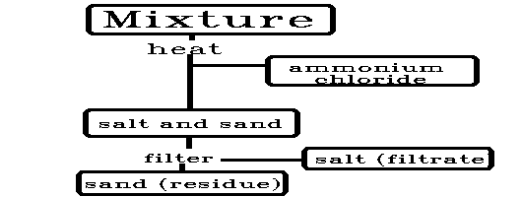be heated in the fume hood. Ammonium chloride sublimes and will be visible as white fumes. The heating will be continued until the white fumes disappear
meaning the ammonium chloride has all been removed. The sand and sodium chloride remain behind.
The second step is to separate the salt and sand. Since salt is water soluble and sand is not, adding water to the mixture will
dissolve only the salt (extraction). When we add water to the mixture, we have saltwater (the liquid above the solid or
supernatant) and the solid, sand. We now need to complete the separation. This will be done by filtration.
The first step in a filtration is to set up the apparatus as illustrated below. A funnel is placed on a ring stand so that the
neck of the funnel is against the side of the receiving beaker. This allows for a continuous flow of water. Water sticks to glass and this
helps pull the liquid through the funnel and make the process more efficient.
The next step is to insert a piece of filter paper into the funnel. First, a weighed piece of filter paper is folded into quarters
forming a triangle. One leaf of this is pulled out, making a cone,
and the filter is placed into the funnel. The filter paper is wetted with water before the filtration.
This serves several purposes. First, it makes the paper adhere to the funnel so it is easier to transfer the mixture. Secondly, it opens the pores on the paper, and third, it starts the flow of water. In addition, it prevents the filter paper from absorbing the substance you are separating.
Once this apparatus is in place, the mixture is quantitatively transferred to the funnel.
When all of the mixture has been poured into the funnel, the original container should be rinsed to ensure that all of the mixture has been transferred.
After the liquid has filtered through, the residue (sand) in the filter is washed with more water to remove any adhering dissolved salt particles. This completed, the filter and residue
(consisting of sand) can be carefully removed from the funnel and allowed to dry. This is easily

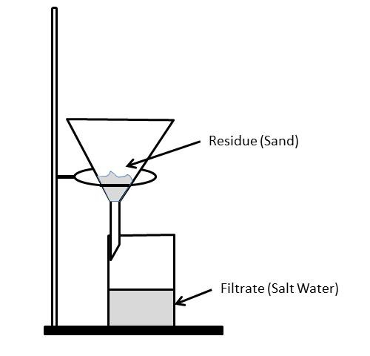will serve to capture any residue that falls off of the filter paper.
The liquid that comes through the filter is
called the filtrate and, in this case, contains salt and water. The best way to purify the salt is to evaporate the water, which is done by transferring the filtrate to a weighed evaporating dish and heating the dish with a Bunsen burner. It is best if a watch glass is placed over the evaporating dish to prevent loss due to splattering of the filtrate. The filtrate can then be heated to dryness and weighed. The percentages of each component of the mixture can be calculated as follows:
The mass of the salt is obtained by subtracting the mass of the evaporating dish and watch glass from that of the evaporating dish and watch glass plus the dried filtrate. The percentage of salt is given by the following relationship:

Equation 1: mass salt x 100%
mass mixture

The mass of the sand is obtained similarly by subtracting the mass of the filter paper and beaker from that of the paper, beaker and dried residue. The percentage of sand is obtained by equation 2.

Equation 2: mass sand x 100%
mass mixture

The mass of the ammonium chloride is determined by subtraction of the mass of the evaporating dish plus the residue after subliming from the mass of the evaporating dish plus the unknown sample before subliming.
The percentage of ammonium chloride in the mixture is determined in a manner analogous
to the calculations used for the other components. It is important not to determine the percentage of ammonium chloride by subtraction from 100% as this will not allow you to find any errors. Instead, it should be calculated as discussed and the three percentages added up to confirm the results. The percentages should add up to 100%

Example: Let’s say that a mixture of salt, sand and ammonium chloride was placed in an evaporating dish of mass 42.157g. With the mixture, the mass was 43.499g. After heating the new mass was 43.323g. The remaining mixture was extracted with water and filtered. The dried residue had a mass of 0.553g. The filtrate was evaporated and found to have a mass of 0.613g. What was the percentage of each component of the mixture?

Solution: The mass of the mixture was

43.499g – 42.157g = 1.342g

The mass of the ammonium chloride is the difference between the mixture before and after heating or:

43.499g – 43.323g = 0.176g ammonium chloride

The mass of the sand was 0.553g and the salt was 0.613g

The percentages are:

% ammonium chloride = mass ammonium chloride x 100% Mass mixture

% ammonium chloride = 0.176g x 100% = 13.1% ammonium chloride
1.342g

% salt = mass salt x 100% = 0.613g x 100% = 45.7 % salt
Mass mix 1.342g

% sand = mass sand x 100% = 0.553g x 100 % = 41.2 % sand
Mass mix 1.342g

Procedure:

NOTE: There are no units given on these data sheets. Don’t forget to record units!!

1. Obtain an unknown mixture and record the unknown number.

2. Weigh an evaporating dish.

3. Transfer the entire unknown sample to the evaporating dish and reweigh.

4. Using a hot plate, heat the unknown in the evaporating dish in the fume hood until the white fumes cease to rise. (There may be a ring of residue on the evaporating dish as the ammonium chloride tends to re-condense. If this appears, using a stirring rod, push it into the evaporating dish and continue heating.)

5. Allow the unknown to cool. Weigh the evaporating dish and sample after subliming.

6. Obtain a piece of filter paper and record its mass.

7. Pour about 10mL of deionized water into the mixture and stir to dissolve the salt.

8. Set up a filtration apparatus as discussed and transfer the entire mixture into the filter allowing the liquid to flow through. Be sure to rinse out the evaporating dish with deionized water to ensure complete transfer.

9. Wash the residue twice with about 10mL of deionized water. Try not to use more than about 25 mL total.

10. After the filtration is complete, place the filter and residue in a weighed beaker and put this in the oven to dry.

11. Carefully transfer your filtrate (salt water) to the weighed evaporating dish. If you use your original evaporating dish, you will not have to reweigh. Do not fill the evaporating dish more than about halfway.

12. Weigh a watch glass.

13. Cover your evaporating dish with the watch glass and heat on a hot plate until the solid is dry. (If you have leftover solution from step 9, you may have to do this in batches.)

14. Allow the evaporating dish and watch glass to cool and record the mass.

15. Allow beaker with sand (from step 10) cool and then record the mass.

16. Determine the percentages of sand, salt and ammonium chloride in your mixture

