I-35 Bridge Collapse

Background
In 2007, the I-35 Bridge crossing the Mississippi River in Minneapolis, MN suddenly collapsed without any warning, instantly plunging 100 cars down to the Mississippi River below.

The pictures are fascinating, but keep in mind this was a human tragedy of enormous scale. 13 persons died and over 100 were injured. It took underwater divers 3 weeks to completely recover all the deceased trapped in the 15-ft deep river. 60 children in a school bus very nearly plunged over the edge.

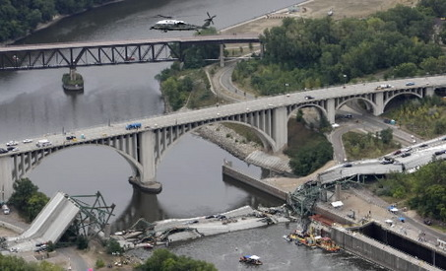
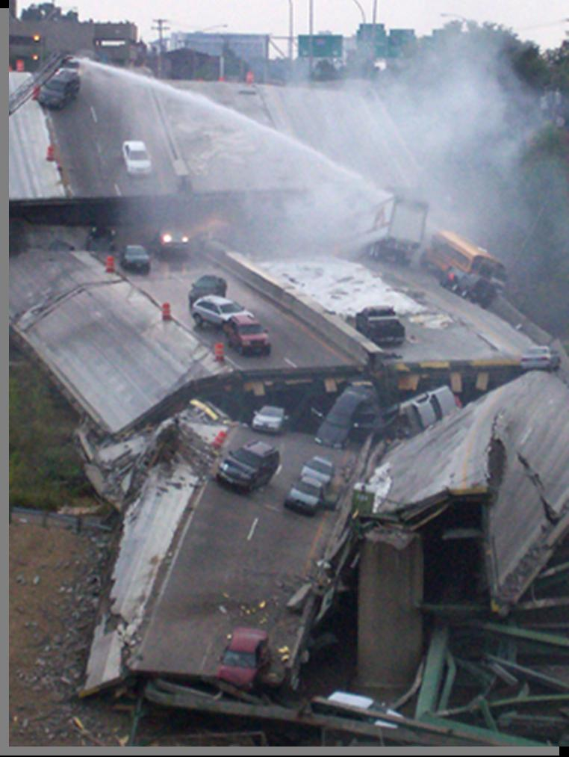
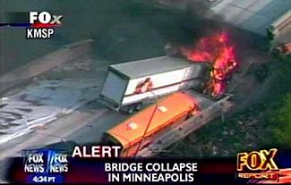

Many factors contributed to the bridge collapsing. We covered these in class…

1. Under-sized steel gussets connecting the main trusses…. They had been buckling for years but never fixed for some reason.
2. Stuck roller bearings on the bridge piers… These were never fixed.
3. Heavy construction materials piled on top of the bridge at the time of collapse (the bridge was being re-paved at the time).
4. Stress cracking noticed on structural members, and documented in several reports… These were never fixed for some reason.
5. Bridge was not designed to carry that much traffic. Built as a 4-lane bridge in 1967, but expanded to 8-lanes at the time of collapse.
6. And several additional factors….

Assignment (100 points possible)
Do internet research on the causes of the bridge collapse, and prepare a PowerPoint presentation with diagrams and pictures. In your PowerPoint report, cover the following:

- Outline and explain the possible causes of the bridge collapse. Explain from an engineering standpoint how each could have contributed to the collapse.

- Who do you think was responsible, and why?

Possibilities: 1) The contractor who piled 500,000 lbs of materials on the bridge before it collapsed? 2) The Dept. of Transportation for reconfiguring the bridge from 4 lanes to 8 lanes, thus doubling the amount of traffic? 3) The Governor and/or state legislature of Minnesota for never fixing the many problems that had been well-documented? 4) The original 1960’s design firm? 5) The original 1960’s contractor? 6) The firm that was paid by taxpayers to inspect the bridge every year? 7) Harsh Minnesota winters? 8) A combination of these?

- If you could go back in time with 20-20 hindsight, what specific actions would you take to prevent the bridge collapse? (assuming you had the power to do so)

- Be prepared to present your report in around 4-5 minutes at an upcoming class.

Resources
There is lots of information and pictures and diagrams on the Internet. You will need to do some research!

