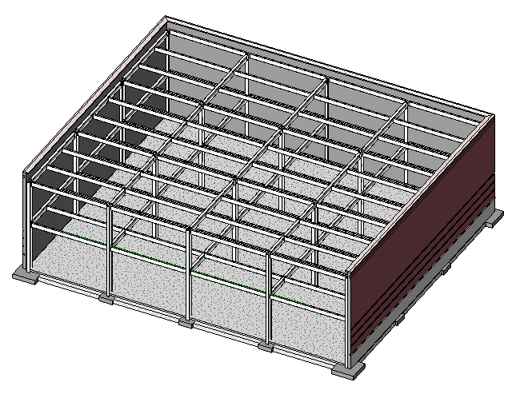

**Retail Building Project**

3D structural layout



Girder

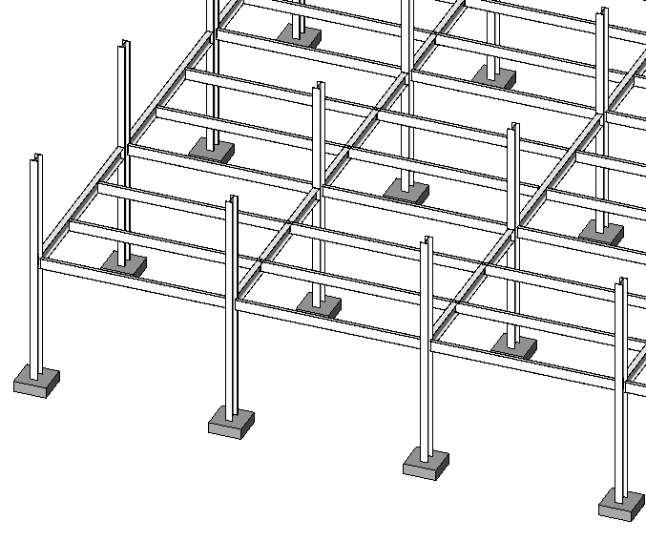

Beam

Footing

Column

**2nd floor framing layout**

For clarity the ground floor slab, 2nd floor slab, roof framing, and roof deck are not shown

