Digestive System
Name and date submitted (3 pts):
Using this handout as a TEMPLATE, write or type your answers in the spaces provided. KEEP THE SAME NUMBERING SYSTEM or you will have points deducted.
(34 questions)
Watch the video “The Digestive System”, posted in Unit 13 on the student portal. It can also be accessed here https://www.youtube.com/watch?v=goSC-1YvHVk
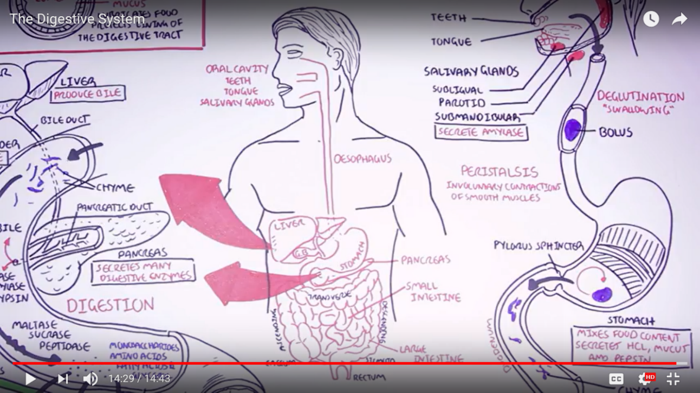

Questions:
- 0:14: What are the six (6) main organs which make up the human digestive tract?

- What are the six (6) “accessory organs”?

- 1:20: What are the three (3) main food types we need to digest?

- 1:50: List the three (3) main layers of the digestive tract AND state their purpose.

Layer | Purpose

- 3:05 The mouth
- What is the role/function of the teeth

- What is the role/function of the tongue

- What is the role/function of the salivary glands

- Name the three (3) salivary glands

- What does the enzyme ‘amylase’ do?

- 4:08 The esophagus
- What is the physiological term for ‘swallowing’?

- What is the food referred to in the esophagus?

- What process drives the food down the esophagus?

- 4:55 The stomach
- What is the basic function of the stomach?

- How many muscle layers does the stomach have?

- What three (3) substances do the stomach cells secrete?

- 5:35 The small intestine
- What is the name of the ‘valve’ located at the bottom of the stomach?

- What is the liquefied food is now called (after the stomach)?

- What are the three (3) sections of the small intestine called?

- True/False: Most of your food digestion takes place in the small intestine, not the stomach.

- 7:00 The liver and gallbladder
- The liver secretes a substance which has a critical role in digestion of fats (lipids). What is this substance called?

- What is the purpose of the gallbladder?

- 8:00 The pancreas
- The pancreas makes many digestive enzymes. How do these enzymes make their way to the small intestine?

- What are three (3) enzymes produced by the pancreas?

- 9:00 Back to the small intestine
- The cells lining the small intestine also produce enzymes. What are three (3) of these brush border enzymes?

- The food (chyme) is broken down into what four (4) types of smaller molecules?

- These four (4) smaller molecules are the building blocks of what three (3) substances in the body?

- How are monosaccharides and amino acids finally absorbed into the body?

- How are fatty acids absorbed into the body?

- What are villi? What do they do?

- 11:15 The large intestine
- What is another name for the large intestine?

- What are the six (6) parts of the large intestine?

- What is the role of the appendix?

- What is the role of the trillions of bacteria in the large intestine?

- True/False: the lining of the large intestine has a thick mucus layer located on top of the villi.

