Hyatt Walkway Collapse case study

Name and date submitted (3 pts):
(4 questions, 100 points)
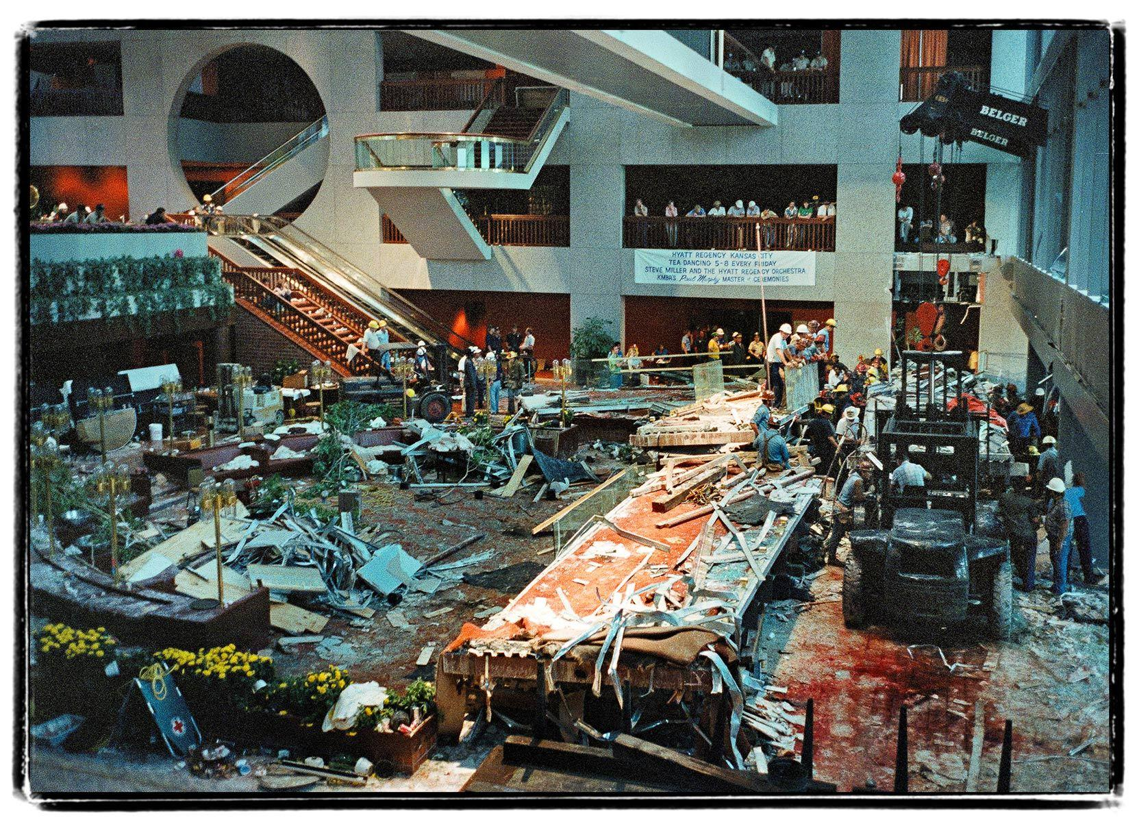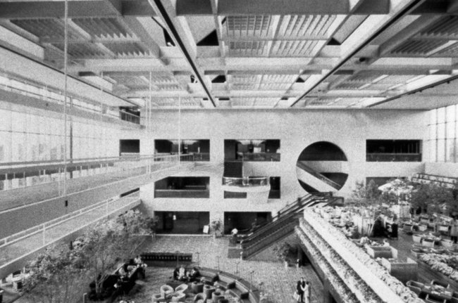

Background
One of the worst engineering disasters in U.S. history was the collapse of the suspended walkway at the Hyatt Regency hotel in Kansas City, which killed 114 people and injured nearly 200 others. An analysis of the walkway's structural inadequacies provides a relevant context to apply what you have learned in this chapter about the nature of forces.

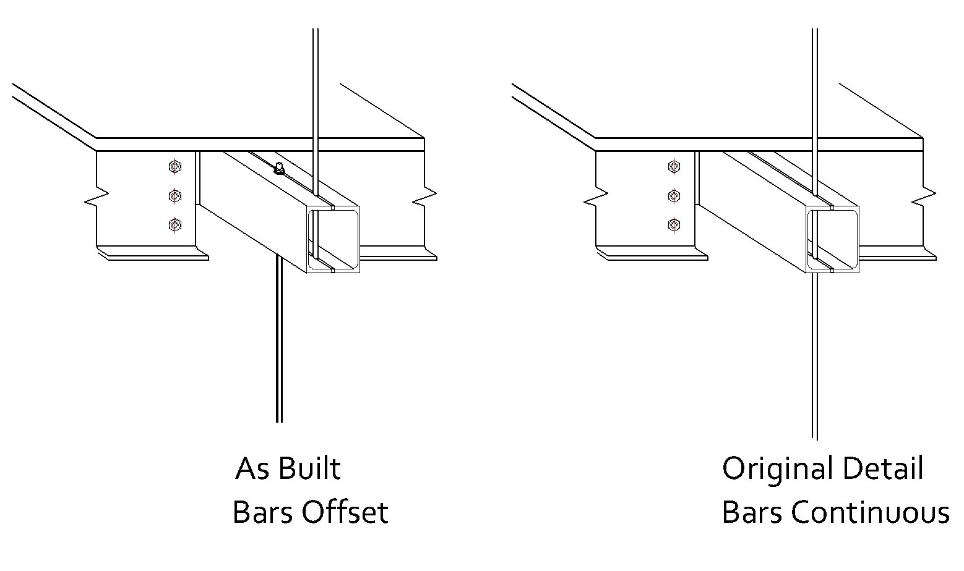The original design for the walkway support system called for a set of continuous tie rods to connect the second- and fourth-floor walkways and suspend them from the ceiling, with the second-floor walkway hanging directly below the fourth-floor walkway. To better understand this configuration, imagine for a moment that you are hanging from a rope that is suspended from a tree branch. A friend of equal weight is holding onto the same rope some distance below you. You are both holding onto the rope with only your hands and transferring your weight to the rope through your grips.

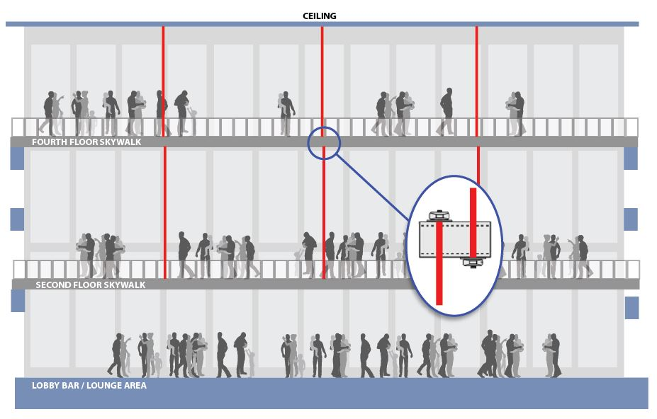
For a variety of reasons, the suspended walkways were not constructed according to the original design.
Rather than using a set of continuous rods to connect both walkways to the ceiling, one set of tie rods was used to connect the second-floor walkway to the fourth-floor walkway and a separate set of tie rods was used to suspend the fourth-floor walkway from the ceiling (as shown in Figure 12-18b). Let's apply a similar design modification to the way that you and your friend are hanging from the tree. Imagine that your rope isn't long enough for you both to hang from the branch using the same rope. Instead, you have two shorter ropes that will effectively accomplish the same objective. In the new scenario, you hold onto one rope that is connected to the tree branch, while your friend hangs from a second rope that is tied to your leg. It does satisfy the same goal, in that you are suspended in tandem from the tree branch. However, the modified design has altered the way in which your friend's weight is now transferred to the rope that's attached to the tree branch. How do you think this new configuration affects the amount of weight that is supported by your grip on the rope?

To understand how changes to the design of the walkway's box beam and rod support system came about, and why the design changes led to the failure of the suspended walkway system, review the handouts/files posted next to this assignment on the student portal:
- Review the Bernhardt article from Structure Magazine.
- Review the Schulman case study (the PPT slides).

Homework instructions
Review the relevant information. Then respond to the following questions. Be sure to include your name and date, and submit as an email attachment by the due date.

- Explain in your own words why you think the box beam system failed to support the load of the patrons. I’m looking for around ½ page of details.

- Refer to Figs. 2 & 3 in the Bernhardt article. If you need to review how to do this problem, look at the example problem on p. 330-331 in your textbook.
  - What was the diameter in inches of the steel rods holding up the walkways?

  - What was their cross sectional area, in square inches?

  - With a yield stress of 36,000 psi, and using a safety factor of 2.5, what was the allowable tensile stress in each rod in psi?

  - Calculate the maximum tensile load in lbs. that each rod should not exceed.

- Read the fallout from the disaster in the Bernhardt and Schulman pieces. Who was found at fault? What happened to them? Did anyone lose their license(s)? Did anyone go to jail? What amount in damages was awarded by the courts?

- How could the disaster have been prevented? Outline the steps.

