Supply & Prices
Name and date submitted (3 pts):
Resources: Refer to the textbook and the class lecture slides posted on the class page.
Instructions: Create space and enter your answers in the Word document below, and then submit as an email attachment. KEEP THE SAME NUMBERING SYSTEM, or you will have points deducted!
- Definitions (p. 65)
- What is the definition of “supply” as stated in your textbook?

- What is the “law of supply” as given in your textbook?

- Supply curves (p. 66)
- Examine Fig. 4-2 in your book. At a price of $1.40 each, how many candy bars are candy suppliers willing to produce? Please note the quantities are in “thousands”.

- Why would candy companies supply fewer candy bars at a price of only $.60 each? The answer may seem obvious, but I’m looking for a well thought-out answer which explains this.

- Shifts in supply curves (p. 67-71)
- Refer to Fig. 4-3. Give three (3) factors which might cause the supply curve to shift to the right as shown in this diagram.

- How could “Changes in Technology” lower the price of candy bars? There are many ways. Try to list 3 or 4 examples.

- How could “Changes in Production Costs” lower the price of candy bars? Again, there are many examples. Think about this and give me 3 or 4 good examples.

- How could “Changes in the Price of Related Goods” lower the price of candy bars? First, think of a Related Product”; then give a well-reasoned answer.

- Market equilibrium (p. 71)
- Define what is meant by “market equilibrium”. Your book has a definition on p. 71, but think about it and state it in your own words.

- What is the equilibrium price of candy bars and quantity produced in Fig.4-9?

- Surpluses and Shortages (p. 74-78)
This is one of the most important topics in this chapter. The next 2 questions will require you to read pages 74-78, think it over, and summarize it in your own words:
  - How does a free-market system adjust itself to a surplus of candy bars? In other words, how do buyers and sellers naturally move the price back to the equilibrium?

  - Now take the other case: How does a free-market system adjust to a shortage of candy bars? In other words, how do buyers and sellers – by pursuing their own self-interests – move the price back to equilibrium?

Note: questions #6-9 refer to the lecture slides posted on the class page.
- Profits
  - Refer to slide #5. Let’s say your chocolate covered jalapeno business had a fantastic February! Your Sales Revenue was $5,000, your Cost of Production was $2,500, and your Overhead was $500.
- What was your Gross Profit for February?

- What was your Net Profit?

- What was your Net Profit as a percentage of Sales?

  - List at least five (5) reasons why a business firm needs profits. In other words, what are profits used for? (hint: see “Profits benefit society” slide)

- Equilibrium
  - Refer to slide #12. What is the equilibrium price of strawberries and quantity produced?

  - At the “surplus” price of $2.50 per kg, how much of a surplus of strawberries results? Please note the quantities are in “millions”.

  - At the “shortage” price of $1.50 per kg, how much of a shortage of strawberries results? Again, please note the quantities are in “millions”.

- Refer to slide #15. Long term, how will strawberry suppliers react to a surplus of strawberries on the market? How will this benefit consumers? Think this one over….

- Refer to slide #14. Long term, how will strawberry suppliers react to a shortage of strawberries on the market? How will this benefit consumers? Think it over before answering....!

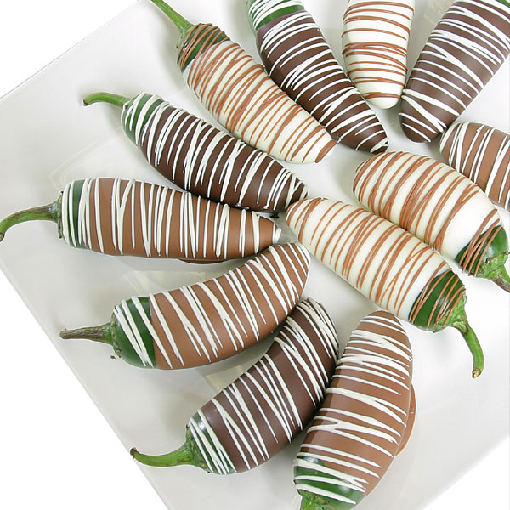
- Revenue and Profit brain teaser:
“You can sell 1,000 chocolate-covered jalapenos a day in the U.S. for $1 each. Since your total cost is $800 a day, you make $200 profit per day. One day you learn of an opportunity to sell 1,000 additional chocolate-covered jalapenos per day in Brazil for $.50 each. If you boosted production to 2,000 jalapenos per day, your total production cost would rise to $1,200, which averages out to $.60 per jalapeno. Should you sell $.60 jalapenos to the Brazilians for only $.50? (Assume you can still sell 1,000 jalapenos per day in the U.S. for $1 each)”. Why? Explain.
Think this through carefully – the answer may not be obvious.

