

|  |
| --- |
| **Activity 1.3.3 Thermodynamics** |

Name and date submitted (3 pts):

Respond to all questions below. KEEP THE SAME NUMBERING. Upload your completed work to Canvas. (20 questions)

Resources: Use your book, the PowerPoint slides, and the lecture notes.

1. Define Thermodynamics

1. Define potential energy and list 2 examples
2. Define kinetic energy and list 2 examples
3. Define the term ‘heat’
4. Explain the concept of ‘conduction’
5. Explain the concept of ‘convection’
6. Explain the concept of ‘radiation’
7. Fill in the table below with the correct scale and unit.

|  |  |  |
| --- | --- | --- |
| **Scale** | **Freezing point of water** | **Boiling point of water** |
| Celsius |  |  |
| Fahrenheit |  |  |
| Kelvin |  |  |

1. Explain what “BTU” stands for, and how 1 BTU is defined
2. Explain what a “Joule” is, and how 1 Joule is defined
3. Explain what a “calorie” is, and how it is defined
4. How is “Power” defined in terms of energy and time?
5. What is the definition of 1 “Watt”?
6. Define the 1st Law of Thermodynamics.
7. Define the 2nd Law of Thermodynamics, including the concept of “Entropy”.
8. If cold water enters your house at a constant temperature of 50⁰F (10⁰C) and an average bathtub holds roughly 45 gallons (170.3 L) of water, how much energy in Joules is needed to raise the temperature of the bathwater to 105⁰F (40.6⁰C)? Water has a specific heat capacity of 1 BTU/lb-⁰F (4,186 J/Kg-⁰C) and 1 gallon of water has a mass of 8.35 lb (3.79 kg).
9. Bathtub problem continued: A cubic foot of natural gas contains 1.071x106 Joules of energy. It will take 17.80 cubic feet of natural gas to heat 189.3 L of water in the bathtub. If the cost of natural gas is $1.27/Therm, what is the ideal cost of heating the bathwater? 1 Therm = 100,000 BTU. 1 BTU = 4,186 J.
10. A 1.00kg piece of aluminum metal at 90.0°C is placed in 4.00 liters (=4.00 kg) of water at 25.0°C. Determine the final temperature (Tf).

Formula: Q = mc∆T

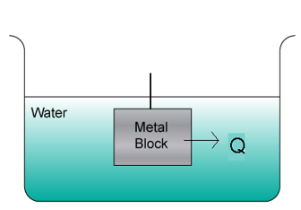

Define the variables:

Q =

m =

c =

∆T =

Solve the problem:

1. 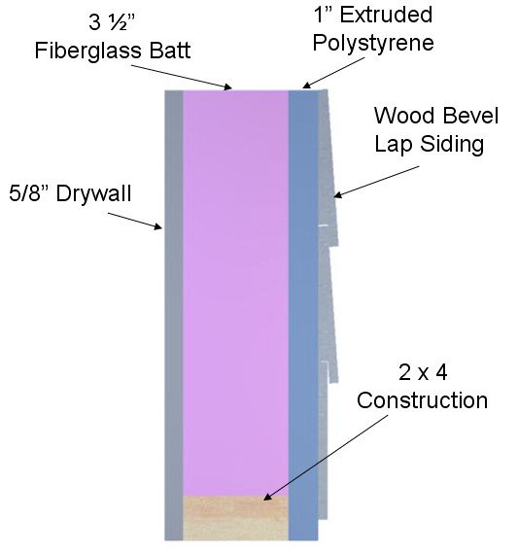Use the R-value chart (attached) to calculate the R- value of the wall cavity shown, and the R-value at the stud location.

R is the thermal resistance of a material. You look it up in a table, then you total it for all the materials. Rtot = R1 + R2 + R3….

a. Wall cavity R-value

b. R-value at stud location

1. A student travels on a school bus in the middle of winter from home to school. The school bus temperature is 58.0 ℉. The student’s skin temperature is 91.4 ℉. Determine the net energy transfer **in Joules** from the student’s body during the 20.00 min ride to school due to electromagnetic radiation. Note: Skin emissivity is 0.90, and the surface area of the student is 1.50 m2.

Stefan’s Law: P = σAe(T24 – T14)

Define the variables:

P =

σ = Stefan’s constant = 5.6696 x 10-8 W/m2-K4

A =

e =

T1 = initial temperature in Kelvin

T2 =

Solve the problem:

|  |  |
| --- | --- |
| **R-Value Chart (R has units of °F-hr/BTU-ft2)** | |
| **Construction Material** | **R-Value** |
| ½ in. Drywall | 0.45 |
| 5/8 in. Drywall | 0.56 |
| Particle Board – ½ in. | 0.63 |
| Particle Board – ¾ in. | 0.94 |
| Fiberboard ½ in. | 1.32 |
| Extruded Polystyrene 1 in. | 4.00 |
| Extruded Polystyrene 1 ½ in. | 6.00 |
| Foil-faced Polyisocyanurate 1 in. | 7.20 |
| 2 x 4 | 4.38 |
| 2 x 6 | 6.88 |
| Hardwood | 0.90 |
| **Masonry Systems** | **R-Value** |
| Brick 4 in. common | 0.80 |
| Brick 4 in. face | 0.44 |
| Concrete Block – Normal wt. 12 in. empty core | 1.23 |
| Concrete Block – Light wt. 12 in. empty core | 2.60 - 2.30 |
| Cement Mortar | 0.20 |
| Sand and Gravel | 0.60 |
| Stucco | 0.20 |
| **Roofing** | **R-Value** |
| Asphalt Roll | 0.15 |
| Asphalt Shingle | 0.44 |
| Slate | 0.05 |
| Wood | 0.94 |
| **Siding** | **R-Value** |
| Wood Shingles | 0.87 |
| Wood Drop | 0.79 |
| Wood Bevel Lapped | 0.80 |
| Aluminum/Steel – Hollow | 0.61 |
| Aluminum/Steel – with 3/8 in. Backer | 1.82 |
| **Insulation** | **R-Value per in.** |
| Fiberglass Batt | 3.142 |
| Blankets – Rock Wool | 3.0 - 3.8 |
| Loose Fill – Cellulose | 2.8 - 3.7 |
| Loose Fill – Fiberglass 0.7 lb/cu.ft | 2.2 - 4.0 |
| Loose Fill – Rock Wool | 3.1 |
| Loose Fill – Vermiculite | 2.2 |
| Extruded Polystyrene | 4.00 |