Activity 3.2.8 Foundation Types and Considerations

Introduction
Someone once said, “It is not the beauty of a building you should look at; it is the construction of the foundation that will stand the test of time.” Although a building is architecturally beautiful and structurally sound, if the foundation cannot safely support it, the building is doomed to failure. An engineer takes many factors into consideration when designing a foundation system. The type of foundation specified for a building depends on the loading, the size and shape of the building, environmental conditions, the soil conditions, and the cost of construction. In this activity you will learn about many different types of foundations and when each is used. You will also investigate soil and environmental conditions for a site to provide information necessary to the design of a foundation.

Equipment
Paper
Pencil

Procedure
Research the following foundation types and draw sketches of each one. Describe the conditions under which each might be used.

Typical Foundation Systems/Usage | Diagram/Sketch
Continuous (Strip) Footing with Stem Wall  A wide strip of reinforced concrete that supports loads from a bearing wall  Usage:  ~ Light frame construction  ~ Under foundation walls | 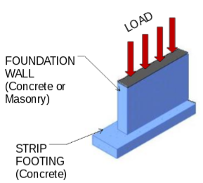
Spread Footing with Pier  A footing that spreads the load over a broad area which supports one (or a few) load(s)  Usage:  Usually used in low-rise buildings | 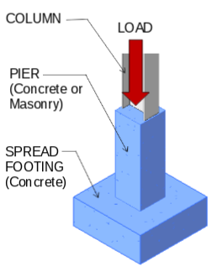
Slab-on-Grade with Thickened Slab  A slab on grade with an integral footing created by thickening the slab  Usage:  ~Residential or light commercial construction  ~Shallow frost depth or when frost protection is used (instead of strip footing) | 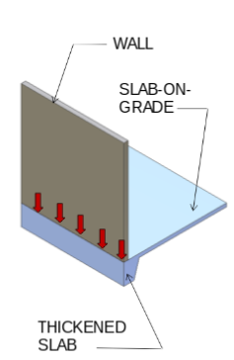
Mat (Floating) Foundation  A large, heavily reinforced concrete slab placed under the entire building to support loads from several points  Usage:  Heavy loads on weak soil | 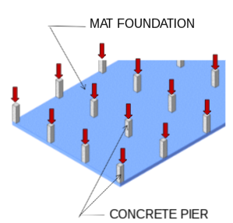
Pile and Pile Cap  Vertical structural member that is driven, jetted, or drilled into the ground in order to gain support from deeper soil layers  Usage:  Weak shallow soil with  deep satisfactory soils | 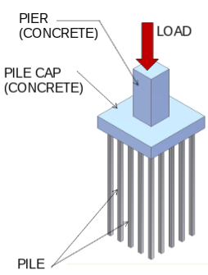
Cast-in-Situ Pile and Grade Beam  A large diameter cast-in-place concrete pile  Usage:  Weak shallow soil with satisfactory soils at intermediate depth | 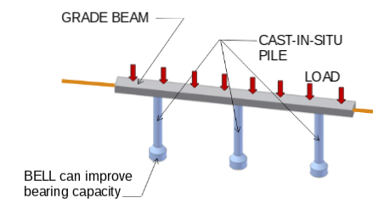

Visit the FEMA Map Service Center at http://www.msc.fema.gov/. Create a FIRMETTE for the Keystone Library Renovation site (Choose FIRMette under What are you looking for?). Then answer the following questions.
Is the Keystone Library Renovation site in an A Zone or V Zone?
The renovation site is in an A zone

How does this affect the building design?
This affects the building design because this means that the school is elevated to or above BFE.

Conclusion
- How do weight and applications of loads affect the design of a structure?
Weight and applications of loads affect the design of a structure because different structures are designed to be able to withstand different things, as things are changed the structure must be changed as well.

What factors determine whether soil is suitable to support a structure?
Many factors affect whether or not soil is suitable to support a structure such as how much the soil can bear. If the soil is unable to hold weight it would not be suitable for for building.
What considerations influence the depth and height of the foundation?
One of the things that should be considered when choosing the depth and height of the foundation is the frost depth, nother thing that should be considered is the flood elevation for that particular area.
4. What are the typical modes of failure of a concrete footing?
The typical modes of failure of a concrete footing are, bending failure, shear failure and punch through, punch through is when structural members punch through concrete, shear failure is when concrete breaks due to excessive shear and bending failure is when the footing bends too much.

