Procedure
The following website contains the information necessary to complete the questions below and to research the properties of soil on your site.

http://websoilsurvey.nrcs.usda.gov

Use your engineering notebook to respond to the following questions. Rewrite the question in your notebook.

- Start the Web Soil Survey by depressing the START WSS button.
- Use the navigation bar to Navigate By… State and County. Define your site as an Area of Interest using the AOI button on the Area of Interest (AOI) tab.

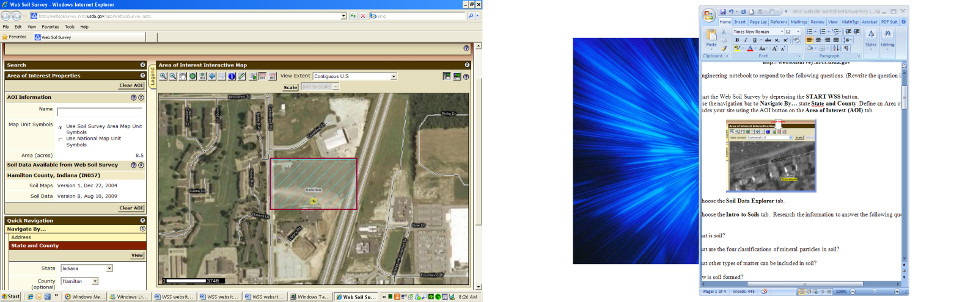

- Choose the Soil Data Explorer tab.

- Choose the Intro to Soils tab. Research the information to answer the following questions in your notebook.

- What is soil?
Soil is a naturally occurring mixture of mineral and organic ingredients with a definite form, structure, and composition. The exact composition of soil changes from one location to another.
- What are the four classifications of mineral particles in soil?
clay, silt, sand, gravel
- What other types of matter can be included in soil?
water, air, organic matter or humus
- How is soil formed?
Soils develop as a result of the interactions of climate, living organisms, and landscape position as they influence parent material decomposition over time.
- What is a soil scientist?
A soil scientist studies the upper few meters of the earth's crust in terms of its physical and chemical properties; distribution, genesis and morphology; and biological components. A soil scientist needs a strong background in the physical and biological sciences and mathematics.
- What is a soil survey?
One of the main tools available to help land users determine the potentials and limitations of soils is a soil survey. A soil survey generally contains soils data for one county, parish, or other geographic area, such as a major land resource area. During a soil survey, soil scientists walk over the landscapes, bore holes with soil augers, and examine cross sections of soil profiles. They determine the texture, color, structure, and reaction of the soil and the relationship and thickness of the different soil horizons. Some soils are sampled and tested at soil survey laboratories for certain soil property determinations, such as cation-exchange capacity and bulk density.
- What type of information does a soil survey provide for construction engineers?
They can be used to determine the suitability and limitations of soils for pipelines, buildings, landfills, recreation areas, and many other uses.

- View the Soil Map (choose the Soil Map tab) and identify the soils that are present on your site by their classification code. Within your design team, assign each of the soil types to a team member for research.
- Choose the Soil Data Explorer tab, then choose the Soils Properties and Qualities tab. Search the data and record the following information for your soil in your notebook. Do not change the default values in the navigation bar, but be sure to include information for All Layers (at the bottom of Advanced Options).

- Liquid Limit
- Organic Matter
- Percent Clay
- Percent Sand
- Percent Silt
- Plasticity Index

- Fill in the following table to display each soil property for each soil. You will have to calculate the Plastic Limit. Use the USCS Soil Classification Chart and Plasticity Graph, to classify each soil using the USCS classification.

Soil Classification | Liquid Limit (percent) | Organic Matter  (percent) | Percent Clay | Percent Sand | Percent Silt | Plasticity Index | Plastic Limit  PL= LL- PI | USCS Classification
Cecil-Urban land complex, 2 to 8 percent slopes | 30.5 | 0.75 | 27.0 | 55.4 | 17.6 | 10.0 | 20.5 | SC
Cecil sandy clay loam, 2 to 8 percent slopes, moderately eroded | 30.0 | 0.75 | 27.0 | 55.4 | 17.6 | 10.0 | 20 | SC
Cecil sandy clay loam, 8 to 15 percent slopes, moderately eroded | 30.5 | 0.75 | 27.0 | 55.4 | 17.6 | 10.0 | 20.5 | SC
Monacan loam, 0 to 2 percent slopes, frequently flooded | 17.5 | 2.50 | 17.0 | 43.5 | 39.7 | 7.5 | 10 | SM-SC

