Final Exam for Anatomy & Physiology
Name and date submitted (3 pts):
Create space in the Word document below, and write or type your answers. Turn in your completed work by the due date.
This is an open-book exam. You may use your textbook and the Internet to research the questions.
(100 questions, 1 point each average, 100 points total)
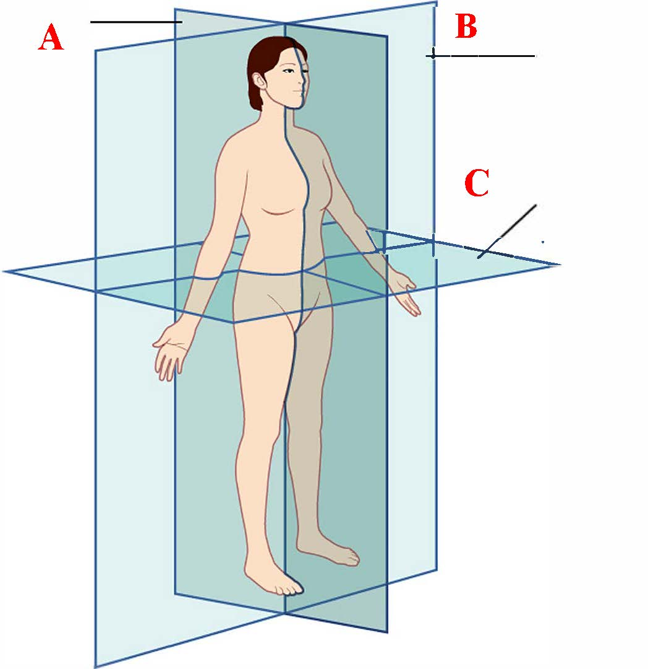The Basics
- Identify the three anatomical planes shown
A.
B.
C.

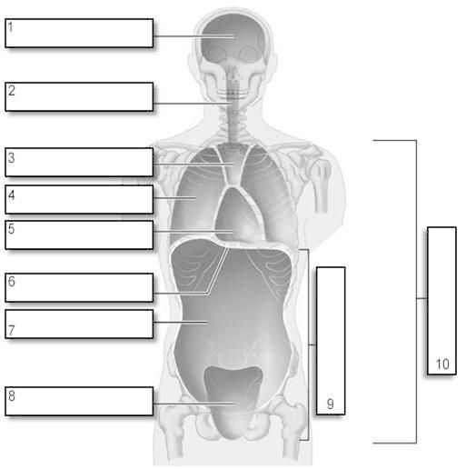
- Identify the following (7) body cavities and/or parts
1)
2)
4)
5)
6)
7)
8)

- The major categories of organic molecules in your body are (choose the best answer)
- Proteins, lipids, water, blood plasma
- Carbohydrates, proteins, sugars, saliva
- Lipids, proteins, carbohydrates, nucleic acids
- Water, blood, saliva, proteins

- Lipids include F______________ and O________________.

- Proteins are made of long strings of A_________ A_______ bonded together and folded up.

- Identify these (4) parts of a ‘long bone’. (Examples of long bones are the femur and the humerus)
- The shaft of the bone is called….
- The end of the bone nearest the body trunk is called….
- The end of the bone furthest from the body trunk is called….
- Technical name for the ‘growth plate’ is….

- Identify these bone cells
- Cells that build-up bone are called…
- Cells that break down bone are called…
- Mature cells that ‘maintain’ the bone are called…

- Give the “common” names of the following (12) bones
- Cranium (example: “skull”)
- Mandible
- Maxilla
- Clavicle
- Scapula
- Humerus
- Radius
- Ulna
- Pelvis
- Femur
- Tibia
- Fibula
- Patella

- Spine: Arrange these (5) from superior to inferior
- Cervical
- Coccyx
- Lumbar
- Sacrum
- Thoracic

- Hand bones: Arrange these (3) from proximal to distal
- Metacarpals
- Phalanges
- Carpals

Muscle Tissue
- Explain what is meant by the “sliding filament mechanism” of muscle contraction. Your answer must include the (5) words “actin, myosin, M line, Z disc, and sarcomere”.

Muscular System
- Give the common name of each muscle, and what it moves or what it does. Use correct words like “extension” and “flexion”.

 | Common name | What does it move? What does it do?
Gluteus maximus | Example: Butt muscle | This group of muscles extends (extension) the upper leg bone (the femur) allowing you to walk, squat, and jump
Rectus abdominis
Hamstrings

Gastrocnemius

- Continued from above…

 | Common name | What does it move? What does it do?
Quadriceps
Biceps
Deltoid

Pectoralis major

- Continued from above…

 | Common name | What does it move? What does it do?
Soleus
Trapezius
Latissimus dorsi

Triceps

- Ordinarily, the attachment point of a muscle to the stationary bone is called the _______________.

- The attachment point of a muscle to the movable bone is called the ______________.

- T/F: Tendons connect muscle-to-bone.

- T/F: Ligaments connect bone-to-bone.

- In producing movements, bones act as L___________, and joints function as the F_______________.

- When the arm is raised like you’re reaching up to catch something, what joint functions as the fulcrum?

- An example of a first-class lever is the head resting on the vertebral column. In this example
  - What is the fulcrum (use correct anatomical terms)

  - What is the effort

  - What is the load

- An example of a second-class lever is when you stand up on your toes. In this example
  - What is the fulcrum (use correct anatomical terms)

  - What is the effort

  - What is the load

- An example of a third-class lever is the bones of the arm and forearm. In this example
  - What is the fulcrum (use correct anatomical terms)

  - What is the effort

  - What is the load

- Exhibit 11.13 – Muscles of the arm that move the forearm: Flex your arm like you’re curling a dumbell….
  - Which group of muscles is contracting?

  - Which group of muscles must relax so that you can flex your arm?

- Exhibit 11.17 – Muscles that move the femur (thigh bone): What is the origin of most muscles that move the femur?

Nervous System
- The branch of medical science dealing with the nervous system is called __________

- A physician who specializes in the nervous system is called a _____________

- The central nervous system (CNS) consists of ____________ and ________________

- The peripheral nervous system (PNS) consists of ____________

- Three functions of the nervous system. Explain what each is and does.

 | What is it? | What does it do?
Sensory
Integrative
Motor

- Name the two subdivisions of the nervous system

- Explain the structure and function of the “cell body”
  - Structure:

  - Function:

- Explain the structure and function of the “dendrites”
  - Structure:

  - Function:

- Explain the structure and function of the “axon”
  - Structure:

  - Function:

- What are Schwann Cells, and what is their function?

- What is meant by “myelination”?

- Explain “resting membrane potential” to an intelligent 5th grader

- How many millivolts (mV) is a typical resting potential?

- What is the synaptic cleft?

- How long is the synaptic delay in milliseconds (msec)?

- Fig. 12.23: Explain how signal transmission occurs at a chemical synapse.

- Explain how nerve impulses are passed from one neuron to the next at the synapse. Be specific.

- Drugs of Abuse: Explain how Cocaine affects neurotransmission. Be specific. Explain the actual physiological mechanism.

Special Senses
- You have 10-100 million smell receptors contained in your olfactory epithelium. Olfact = _____

- The olfactory epithelium consists of olfactory receptors, supporting cells, and basal cells. Briefly explain the structure AND function of each

 | Describe its structure | Explain its function
Olfactory receptors
Supporting cells
Basal cells

- Gust = ___________

- List the five primary tastes

- Each of your 10,000 taste buds consists of supporting cells, gustatory receptor cells, and basal cells. Explain the structure AND function of each

 | Describe its structure | Explain its function
Supporting cell
Gustatory receptor cell
Basal cell

- More than __________ of your sensory receptors are located in the eyes.

- In the electromagnetic spectrum, visible light ranges from about ________ nm to __________ nm in wavelength.

- Describe the structure AND function of the cornea
  - Structure:

  - Function:

- Describe the structure AND function of the sclera
  - Structure:

  - Function:

- Describe the structure AND function of the iris
  - Structure:

  - Function:

- Describe the structure AND function of the pupil
  - Structure:

  - Function:

- Describe the structure AND function of the retina
  - Structure:

  - Function:

- What is the function of rods?

- What is the function of cones?

- Lacrimal Apparatus: Lacrim = ____________

- Give the structure AND function of the auricle
  - Structure:

  - Function:

- Give the structure AND function of the tympanic membrane
  - Structure:

  - Function:

- Give the decibels (dB) of
  - Rustling leaves _____
  - Whispered speech ______
  - Normal conversation ______
  - Vacuum cleaner _________

- Continued from above…
  - Shouting ________
  - Nearby motorcycle or jackhammer ________
  - Uncomfortable threshold _______
  - Painful threshold ________

Digestive System
- Human digestive system: Briefly state the role/function of each, and how it contributes to the overall digestive system.

 | Role: What does it do? What does it contribute?
Mouth | Example: chewing (mastication) of food, and has enzymes which start breaking down carbs
Parotid gland
Esophagus
Stomach
Liver

- Continued from above…

Role: What does it do? What does it contribute?
Pancreas
Gallbladder
Sm. intestine
Lg. intestine
Rectum

The Blood
- Cardiovascular System: cardio = _________________, vascular = ________________

- The cardiovascular system consists of three interrelated components

- The branch of science concerned with blood is called _______________

- State the three functions of blood

- The “formed elements” of blood include three principal components
  - R
  - W
  - P

- Red Blood Cells (RBCs) are called Erythrocytes: erythro = ____________, cyte = ____________

- The oxygen carrying protein in RBCs is called ___________

- What is the diameter in µm of an RBC ?

- The condition where too-little oxygen enters the blood is known as h____________

- White Blood Cells (WBCs) are called L______________

- Platelets are called T__________

- Table 19.3: How do platelets stop bleeding?

- The surface of your Red Blood Cells (RBCs) contain special antigens called A___________

- Your blood plasma contains antibodies called A___________.

- Anemia: symptoms and causes?
  - Symptoms

  - Causes

- Sickle-Cell Disease: symptoms and causes?
  - Symptoms

  - Causes

- Leukemia: symptoms and causes?
  - Symptoms

  - Causes

Lymphatic System & Immunity
- What is meant by the term “pathogen”?

- What is meant by the term "barrier immunity"?

- What is meant by the term "innate" immune system?

- What is meant by the term "adaptive" immune system?

- What is a virus and how does it work?
- What is it? I mean really, what is it?

- How does it operate?

- How does a vaccine work? What is the mechanism by which it works?
- How does it work? I mean really, how does it work?

- How can foreign bacteria enter the body? List at least 5 “routes of entry”.
  - Example: through the lungs

Respiratory System
- The respiratory system consists of (complete each word)
  - N
  - P
  - L
  - T
  - B
  - L

- Anatomical term for “throat” ____________

- Anatomical term for trap door which seals off airway during swallowing ____________

- Anatomical term for “windpipe” ____________

- Each lung is surrounded and protected by a membrane called ______________

- Inhalation is technically called __________

- Air moves into the lungs (choose best answer)
  - Because your nose and mouth function together with your lungs to push air down the trachea, filling the lungs as needed
  - Because your diaphragm muscle flattens or lowers, increasing the volume of the lungs, thus drawing air into the lungs due to pressure difference
  - Because your diaphragm muscle contracts and raises, drawing the right amount of air into the expanding lungs
  - Because when your autonomous nervous system senses that you need a breath, it causes the lung muscles in the right and left lobes to expand, thus increasing lung volume and drawing air down the trachea

- Exhalation is technically called ___________

- The volume of one breath is called __________

- The volume of air inhaled and exhaled each minute is called _____________

- Hemoglobin: The heme portion of hemoglobin contains four _______________, each capable of binding to _________________.

- Hemoglobin (choose best answer)
  - Is a protein molecule contained within white blood cells (leukocytes) that carries oxygen and carbon dioxide
  - Is a protein molecule contained within red blood cells (RBC’s) that carries oxygen to, and carbon dioxide from, the body
  - Is a protein molecule contained within red blood cells (RBC’s) that carries oxygen and glucose (blood sugar)
  - Is a protein molecule contained within red blood cells (RBC’s) that carries oxygen from, and carbon dioxide to, the body

Metabolism & Nutrition
Since you just completed the homework for this Unit, it will not be repeated on the final exam

