Halogen Compounds Lab Report
- Author: Annika Balkam
Date of Experiment: 11/15/19
Date Report Submitted: 12/9/19
Class: Chemistry

- Problem Statement: The purpose of this experiment is to demonstrate how chlorine gas ammonia gas can be made in a home lab, and to observe how it reacts with other elements. In addition, this experiment will demonstrate how to make iodine gas.
- Materials and Methods: Liquid Bleach (Clorox) Water
½ tsp of lye
½ tsp of sodium bisulfate Small candle
Steel wool
Three Erlenmeyer flasks 4 “L” shaped glass tubes Rubber tubing
  - one hole stopper 2 two hole stopper Glass jar
  - g of potassium iodide 4 g of sodium bisulfate
2 g of manganese dioxide Sulfuric acid
Butane torch Ring stand clamp
First, we produced chlorine gas by filling one flask with 1 inch of liquid bleach, and one flask with water and dissolved lye. We added ½ tsp of sodium bisulfate to the flask with bleach, and then sealed the flasks with the stoppers and fitted them with “L” shaped glass tubes and rubber tubing. Once the chlorine gas was collected, we lowered a small burning candle and then a small burning wad of steel wool into a flask filled with chlorine gas. In the second part of the experiment, we produced iodine gas by mixing together 2 g of potassium iodide, 2 g of manganese dioxide, 4 g of sodium bisulfate and sulfuric acid in a small glass jar. We attached it to a ring stand and gently heated the mixture with a butane torch, until fumes emerged.

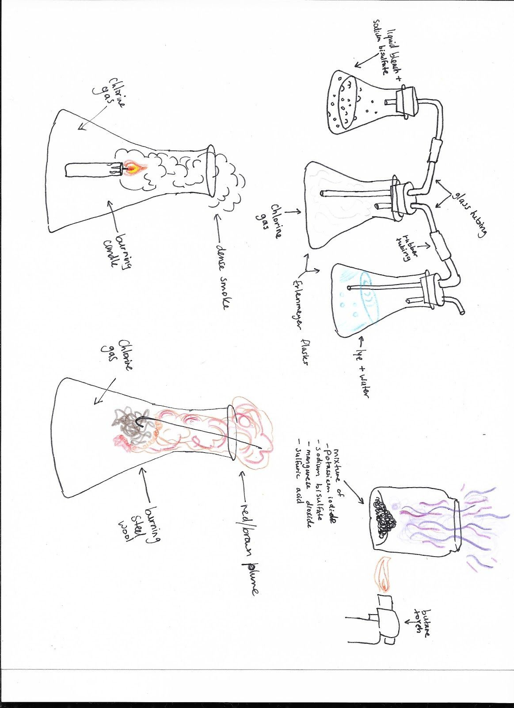

- Results:
As a result of mixing liquid bleach with sodium bisulfate, we were able to collect the chlorine glass in one of the flasks. The excess chlorine gas was was absorbed by the lye water. When the chlorine combined with the hydrogen of the candle, a dense dark cloud of smoke formed. When the chlorine combined with the iron from the steel wool, a red brown plume was formed. As a result of mixing potassium iodide, sodium bisulfate, manganese dioxide and sulfuric acid, we were able to produce iodine gas that appeared as a maroon plume.
- NaClo + NaHSO₄ →Cl₂↑ + other things
- Cl₂ + Fe → FeCl₂ (red brown plume)
- Cl₂ + C₃₁H₆₄ →C + Hcl
- KI + H₂SO₄ + MnO₂→ I₂↑ (maroon plume) + K₂SO₄ + others

- Conclusion:
In conclusion, this experiment demonstrated that we can produce chloride gas by mixing liquid bleach and sodium bisulfate. We were able to observe how that chlorine gas interacted with other elements, such as iron and hydrogen. These interactions demonstrated how chlorine enhances the combustion of other substances. We also learned that we can produce iodine gas by mixing together potassium iodide, sodium bisulfate, manganese dioxide and sulfuric acid, and applying heat.

