Hydrogen Lab Report
- Author: Annika Balkam
Date of Experiment: 10/18/19
Date Report Submitted: 11/4/19
Class: Chemistry

- Problem Statement: The purpose of this experiment is to demonstrate how hydrogen can be collected in a home lab, and how hydrogen reacts when mixed with air.

- Materials and Methods:
A “pneumatic trough”, consisting of a water filled tray with a metal bridge 2 Erlenmeyer Flasks
2 Two-hole stoppers Rubber tubing
- glass tubes
- small zinc strips Test tube Hydrochloric Acid Water
Splint Pipette
Large plastic syringe
First we poured equal parts water and hydrochloric acid into one of the flasks. In the other flask, we placed the zinc strips. Then we fitted both flasks with two-hole stoppers and two pieces of glass tubing each, connected by rubber tubing. Next, we filled the test tube with water, placed it upside down in the pneumatic trough and positioned the rubber tubing connected to the flasks, under the test tube in a way that the hydrogen could fill the test tube. We then used the syringe to push air into the first flask. Once the water drained from the test tube and filled with hydrogen gas, we removed the test tube from the trough and placed a lighted splint inside.
- Results:
When we added the hydrochloric acid (2Hcl) to the zinc(Zn), hydrogen gas (H₂) and zinc chloride(ZnCl₂) was formed. The hydrogen gas bubbled into the water in the pneumatic trough, which we were able to collect in a test tube. When we brought the lighted splint into the test tube, the hydrogen burned at the mouth of the tube, and the flame was extinguished. Because the hydrogen was mixed with air, the result was an explosive “popping” noise.
  - Zn + 2Hcl →H₂↑ + Zncl₂
2) 2H₂ + O₂ →🔺2H₂O + “pop”

- Conclusion:
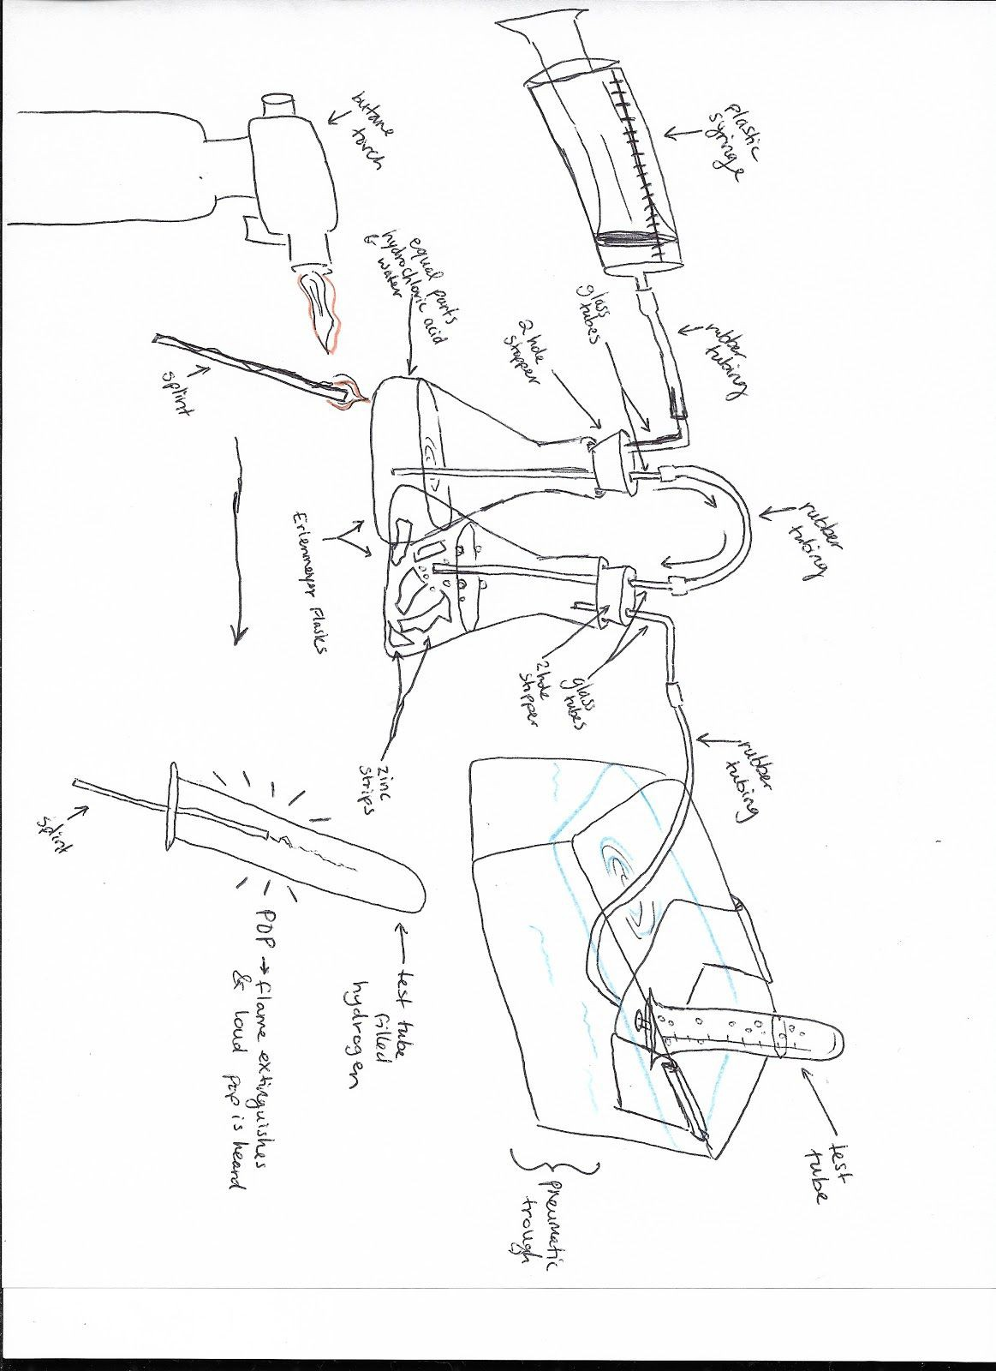
In conclusion, this experiment demonstrated that we can make pure hydrogen gas by mixing together hydrochloric acid and zinc. With the aid of the pneumatic trough, we were able to make hydrogen in a home lab. We also learned that although hydrogen is the lightest known gas, it is highly combustible when mixed with air. In addition, we discovered that the explosion of pure hydrogen gas mixed with air, creates a “po

