Josh Guy
11/4/19
Chemistry
- Hydrogen Lab Report

- Hydrogen can be made in a lab.

- Materials: Test tubes, balloon, zinc strips, candle, Erlenmeyer flasks, pneumatic pump, rubber tubing, glass tubing, deep glass tray, water, hydrochloric acid, butane torch, ring stand, two tongs, two hole rubber stoppers, a long rod (or anything a few feet long), strip of tin can, and charcoal (or pebbles).

Method: Create the same glass tray setup as the Oxygen Lab. Create the “bridge” by placing the strip of tin in the water filled tray, having it hook onto the sides. But this time, the glass tray sits on the base of the ring stand, which has a test tube suspended by two tongs dangling above. Then create the safety glass generator. The short L shaped glass tube coming from the the first hole of the flask 1 two hole stopper connects to the pump and the long tube connects to flask 2’s long tube. Flask 2’s short L shaped tube has the rubber tubing running all the way to the outlet in the trough. Fill flask 1 2/3 full of a mixture that consists of half water and half hydrochloric acid. For flask 2, place 1 inch (or a few pinches) of charcoal (or pebbles) in the bottom of it, then put the zinc strips on top. Seal the flask airtight with the two hole stopper. Use the pump to shoot the acid-water mix from flask 1 into flask 2. As soon as hydrogen starts to bubble up through the water in the pneumatic trough, hold a test tube upside down, over the outlet to collect the hydrogen. When you’re ready, light a candle and insert it into the upside down test tube filled with hydrogen. Since hydrogen is lighter than air, it will remain in the test tube and when it comes in contact with the candle… Pop!

- Zn + 2HCl —> H2 ⬆️ + ZnCl2
(Zinc) (Hydrochloric (Hydrogen (Zinc chloride)
acid) gas)
^
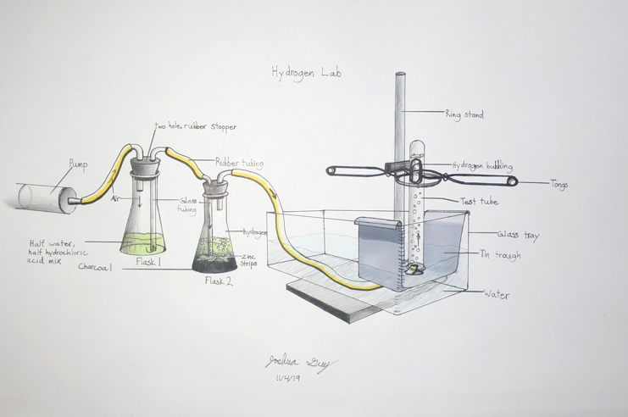
- 2H2 + O2 —> 2H2O + “pop”
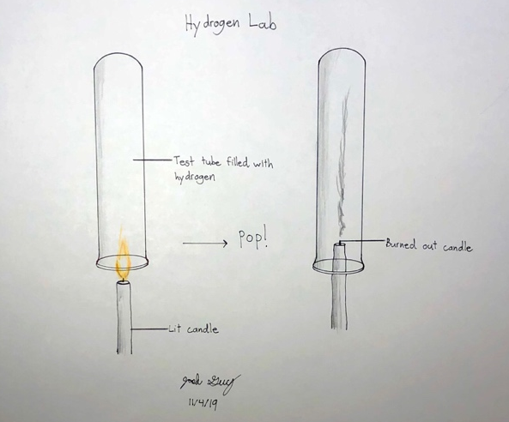

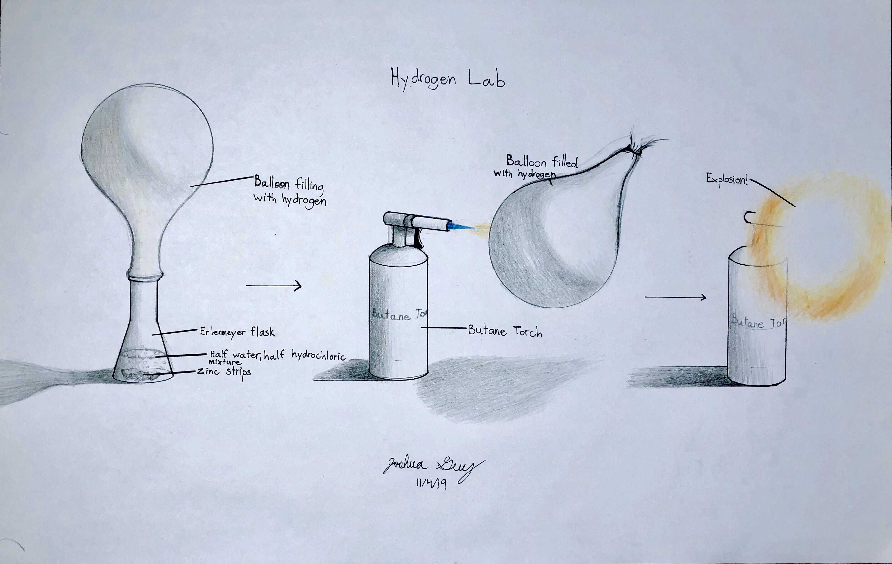
For the last part, fill an Erlenmeyer flask ¼ full with a half and half mixture of hydrochloric acid and water. Drop in a few zinc strips, fit the balloon around the mouth of the flask, and wait for it to inflate with hydrogen. Then secure the inflation of the balloon (we used a pair of scissors holding the end of the balloon), place the butane torch on the ground with flame turned on, attach balloon to a long rod (or something with enough length to keep your hands safe from the explosion), drag the balloon into the flame, and watch it explode!

- Results: We successfully created hydrogen in our labs and proved it’s combustibility.

- Conclusion: We discovered that you can create hydrogen via reacting zinc strips, charcoal, water, and hydrochloric acid together. And tested that it was indeed hydrogen by putting it through the combustion test with the balloon. I learned that hydrogen would stay put in an upside down test tube because it is lighter than air, I assumed it would just diffuse into the air but was surprised.

