iPhone Marketing Plan
Your name and date submitted (3 pts):
Instructions: Download the original 2007 Apple iPhone ‘Generation-1’ marketing plan which is posted on the student portal. Create space in the TEMPLATE below and respond to the following questions.
(10 questions, 5 points each)
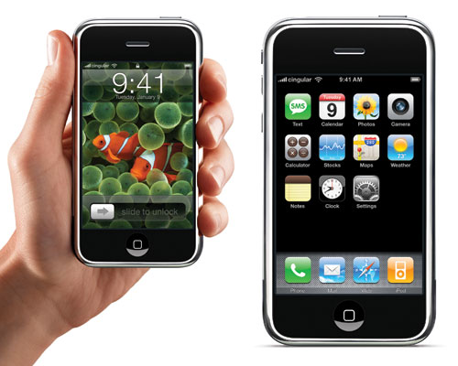The picture shows the original ‘Generation-1’ phone, circa 2007.
Market Summary (p. 1)
- Read the market summary
  - List the 5 groups they are targeting

  - Why do they think the market is “small”?

  - Why do they think the market will “rapidly increase”?

SWOT Analysis (p. 2-3)
- What do they think are the iPhone’s 6 biggest “strengths”? List them here, and summarize IN YOUR OWN WORDS.

- What do they think are the iPhone’s 3 biggest “weaknesses”? List them here, and summarize IN YOUR OWN WORDS.

- What do they think are the iPhone’s 3 biggest “opportunities”? List them here, and summarize IN YOUR OWN WORDS.

- What do they think are the iPhone’s 3 biggest “threats”? List them here, and summarize IN YOUR OWN WORDS.

Product Offering (p. 3-4)
- Explain these product features IN YOUR OWN WORDS
  - Phone

  - Camera

  - Style

Objectives (p. 4)
- State their 1st year objectives IN YOUR OWN WORDS

- State their 2nd year objectives IN YOUR OWN WORDS

Pricing (p. 5)
- What is their pricing strategy, including the specific dollar amounts? Why are they taking a low-price-strategy?

Distribution (p. 5)
- Explain their distribution “roll-out” plan IN YOUR OWN WORDS

