**Midterm Exam: Anatomy & Physiology**

Name and date submitted (3 pts):

Create space in the Word document below, and write or type your answers. KEEP THE SAME NUMBERING SYSTEM and all the original questions, or you will have points deducted. This is an open-book exam. DO YOUR OWN WORK. The exam contributes 25 percent of your semester grade.

(30 questions with approximately 130 sub-parts, average 1 point each, 130 points possible)

1. Identify the three anatomical planes shown in the figure

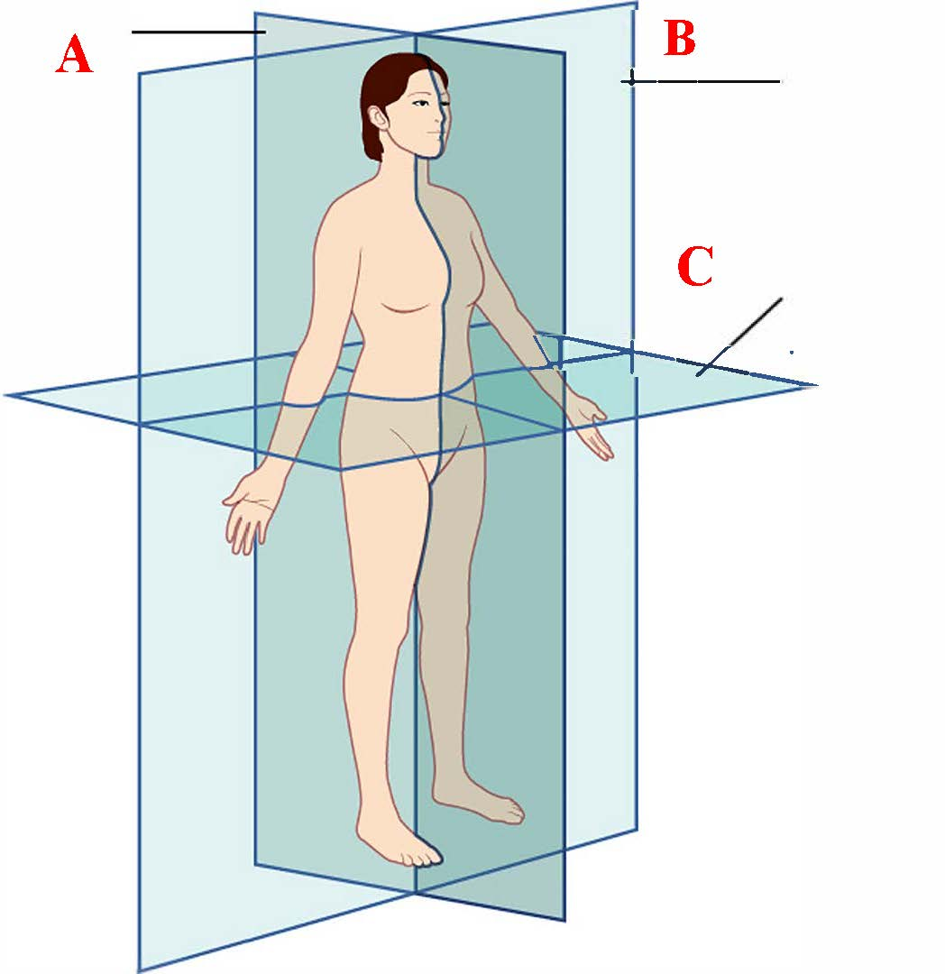

1. Levels of Structural Organization: Fill in the missing levels, going from simple to complex
   1. Chemical level



   6. Organismal level

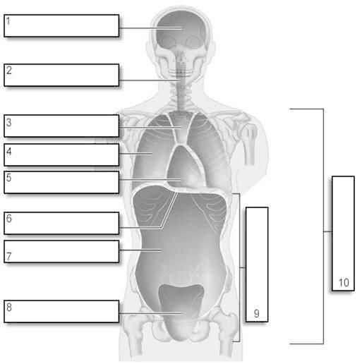

1. Body Cavities: Identify the following body cavities and/or parts in the figure

1)

2)

3, 4, & 5 together)

6)

7)

8)

1. Directional Terms: Supply the correct, anatomical term for the following:
   1. Nearer to the midline =
   2. Further from the midline =
   3. Above =
   4. Below =
   5. Front =
   6. Back =
   7. Nearer to the trunk =
   8. Farther from the trunk =
2. Medical Imaging: Supply the formal term for the following procedures
   1. A single barrage of x-rays that produces an image on film
   2. High frequency sound waves reflect off body tissues and produce an image on a video monitor
   3. A high energy magnetic field is used to produce a color-coded image of body fluids and tissues
   4. X-rays are used at multiple angles around a section of the body, producing a detailed image in various shades of gray
   5. A radioactive substance is introduced intravenously, producing a color image on a video monitor
3. On her Anatomy & Physiology midterm exam, Sally defined homeostasis as “the condition in which the body approaches room temperature and stays there.” Do you agree with Sally’s definition? Why or why not?
4. Organic Compounds: The major categories of organic molecules in your body are (choose the best answer)
5. Proteins, lipids, water, blood plasma
6. Carbohydrates, proteins, sugars, saliva
7. Lipids, proteins, carbohydrates, nucleic acids
8. Water, blood, saliva, proteins
9. Chemical Reactions: Chewing a bite of bread mixes it with saliva and facilitates its chemical breakdown. This is most likely due to the fact that
10. The inside of the mouth maintains a very high temperature
11. Chewing stores potential energy
12. Chewing facilitates synthesis reactions
13. Saliva contains amylase, an enzyme
14. Chemical Reactions: The purpose of a CATALYST is to speed up a chemical reaction.
15. Catalysts in the body are called ___________.
16. These are made of P____________.
17. pH Scale: We measure acids and bases using the pH Scale.
18. Substances below 7.0 are _______________.
19. Substances above 7.0 are _______________.
20. Vinegar and coffee are examples of ____________.
21. Baking soda and soap are examples of ____________.
22. Lipids include the organic molecules known as F________ and O__________.
23. Proteins are built from long chains of ____________ bonded together and folded up into 3D shapes.
24. (see textbook) Carbohydrates include S_________, Gl___________, St____________, and Ce_____________.
25. Nucleic Acids are DNA and RNA
    1. DNA stands for
    2. RNA stands for
26. Parts of a Cell: Identify the main parts of a human cell (a Eukaryotic cell)
27. The “international border”. Separates cellular contents from the tissues and fluids outside the cell.
28. The “head office”. Contains the genetic material, or DNA, which encodes for proteins.
29. The “head office security”. Protects the genetic material from the contents of the cell.
30. The “environment”. The gel-like contents of the cell, containing the organelles and fluid.
31. The “power plant of the cell”. Produces most of the cell’s energy in the form of ATP.
32. The “protein assembly machine”. The 2-part machine where amino acids are assembled into proteins from the information contained on the mRNA.
33. The “post office”. Modifies and packages proteins and sends them where needed.
34. The “highway system” and “beams” of the cell factory. Provides strength and form to the cell, and provides cable “roads” for transporting components around the cell.
35. Chromosomes
    1. What is a chromosome?
    2. What do they do?
    3. How many do you have in each of your cells?
36. Genes
    1. What is a gene?
    2. What does it do?
    3. Approximately how many genes does a human have?
37. Henrietta Lacks case study
38. What was unique about Lacks’ tumor cells?
39. What is meant by an “immortal cell line”?
40. Before HeLa cells were available, how did researchers study Polio?
41. What caused Mrs. Lacks’ cervical cancer? (be specific, name the causative agent)
42. What was the main problem in growing/culturing human cells before 1951, before HeLa cells became available?
43. Types of Tissues: Name the four basic types of tissues in the human body
44. Cell Junctions hold cells together. There are 5 types of cell junction (see Ch. 4). Supply the formal name to each description below.
    1. Cells held together by weblike strands of transmembrane proteins (like stitching)
    2. Cells have tunnels called connexons to allow “communication”
    3. Cells held together by cadherins and plaque arranged in a ‘belt’
45. Epithelial Tissue: Skin is a type of epithelial tissue. There are 4 cell shapes. Supply the formal name to each description below.
    1. Flat, like floor tiles
    2. Tall, like a column
    3. Square, like a cube
    4. Able to change their shape, and then return to normal
46. Integumentary System: Structure of the Skin – Provide the correct anatomical term for each of the following
    1. The superficial (outermost) layer of skin
    2. The deeper, thicker layer of skin
    3. The layer right under ‘b’, consisting of adipose (fatty) tissue
    4. Skin cells that produce keratin
    5. Skin cells that produce the pigment “melanin”
    6. The ridges and grooves on your fingers (which produce fingerprints) are called
    7. Hard protein that makes up nails and hair
    8. Muscle that causes hair to stand erect and goose bumps
    9. Gland that secrets oil called sebum
    10. Glands that release perspiration
    11. Glands that produce ear wax
    12. The white, crescent part of the fingernail
47. Bone Tissue: Identify the four types of bone cells
48. Cells that build-up bone
49. Cells that break down bone
50. Mature cells that ‘maintain’ the bone
51. Stem cells that eventually become bone-building cells
52. Identify the type of bone fracture:
    1. Broken ends of bone stick out of the skin
    2. One side of the bone breaks, the other side bends
    3. Bone is splintered or crushed
    4. Bone develops microscopic fissures from repeated, strenuous activities
53. Identify the parts of a ‘long bone’. Examples of long bone are the femur (thigh) and the humerus (upper arm).
54. The shaft of the bone
55. The end of the bone nearest the body trunk
56. The end of the bone furthest from the body trunk
57. Membrane which surrounds the bone
58. Membrane which lines the inside of the hollow portion
59. Technical name for the ‘growth plate’
60. Sally Harper case study (see section on Aging and Bone Tissue)
61. What is the cause of osteoporosis? Be specific. What is going on, physiologically speaking?
62. Give 2 reasons why it effects women more often than men.
63. Your textbook lists 3-4 ways to treat and prevent or slow osteoporosis. What are they?
64. Auto Crash Spine Injury case study (handout in Unit 7):
65. Which two vertebrae are impinging on the spinal cord in the x-ray?
66. Which vertebra contains the “dens” or odontoid process which is damaged in the x-ray?
67. What is the main “contributing factor” of auto fatalities each year?



1. Write the following (12) bones in the correct location on the figure shown

Skull

Mandible

Clavicle

Scapula

Humerus

Radius

Ulna

Pelvis

Femur

Tibia

Fibula

Patella



1. Write the following (5) sections and bones in the correct location on the spine diagram shown

Lumbar

Thoracic

Cervical

Sacrum

Coccyx



1. Write the following (5) hand bones on the figure shown

Carpals

Metacarpals

Phalanges

Radius

Ulna