**CHAPTER 8**

**ZINC-CARBON BATTERIES (Leclanche´ and Zinc Chloride**

**Cell Systems)**

**Dennis W. McComsey**

***8.1 GENERAL CHARACTERISTICS***

Zinc-carbon batteries have been well known for over a hundred years. The two types of zinc-carbon batteries that are popular now are the Leclanche´ and zinc chloride systems. Both systems remain among the most widely used of all the primary battery systems worldwide, although their use in the United States and Eurrope is declining. The use of ﬂashlights, portable radios, and other moderate and light drain applications, as well as the absence of a high drain device base, is stimulating the use of zinc-carbon batteries in the emerging third world countries. The battery is characterized as having low cost, ready availability and ac- ceptable performance for a great number of applications.

Historically, the ﬁrst prototype of the modern dry cell was the Leclanche´ Wet Cell de- veloped by a telegraphic engineer, Georges-Lionel Leclanche´ in 1866. The design resulted from the need to provide a more reliable and easily maintained power source for telegraphic ofﬁces. The cell was unique in that it was the ﬁrst practical cell using a single low-corrosive ﬂuid, ammonium chloride, as an electrolyte instead of the strong mineral acids in use at the time. This rendered the cells relatively inactive until the external circuit was connected. The cell was inexpensive, safe, easily maintained and provided excellent shelf (storage) life with adequate performance characteristics.

The cell consisted of an amalgamated zinc bar serving as the negative electrode anode, a solution of ammonium chloride as the electrolyte, and a one-to-one mixture of manganese dioxide and powdered carbon packed around a carbon rod as the positive electrode or cath- ode. The positive electrode was placed in a porous pot, which was, in turn, placed in a square glass jar along with the electrolyte and zinc bar. By 1876, Leclanche´ had evolved the design removing the need for the porous pot by adding a resin (gum) binder to the manganese dioxide-carbon mix. In addition he formed this composition into a compressed block by use of hydraulic pressure at a temperature of 100°C. Leclanche´’s inventiveness brought together the major components of today’s zinc-carbon battery and set the stage for conversion from the ‘‘wet’’ cell to the ‘‘dry’’ cell concept.

Dr. Carl Gassner is credited with constructing the ﬁrst ‘‘dry’’ cell in 1888. It was similar to the Leclanche´ system except that ferric hydroxide and manganese dioxide were used as the cathode. The ‘‘dry’’ cell concept grew from the desire to make the cell unbreakable and spill-proof. His cell provided an unbreakable container by forming the anode from zinc sheet into a cup, replacing the glass jar. He then immobilized the electrolyte by using a paste containing plaster of Paris and ammonium chloride. The cylindrical block of cathode mix (called a *bobbin*) was wrapped in cloth and was saturated with a zinc chloride-ammonium chloride electrolyte. This reduced local chemical action and improved the shelf life. Gassner, as did others, replaced the plaster of Paris with wheat ﬂour as an electrolyte-gelatinizing agent and demonstrated such a battery as a portable lighting power source at the 1900

World’s Fair in Paris. These advances were instrumental in establishing industrial production and commercialization of the ‘‘zinc-carbon dry cell’’ and led to the evolution of ‘‘dry-cell’’ portable power.

**TABLE 8.2** Major Advantages and Disadvantages of Leclanche´ and Zinc-Chloride Batteries

Standard Leclanche´ battery

Advantages Disadvantages General comments

Low cell cost

Low cost per watt-hour

Large variety of shapes, sizes, voltages, and capacities

Various formulations

Wide distribution and availability

Long tradition of reliability

Low energy density Poor low temp service Poor leakage resistance

under abusive conditions

Low efﬁciency under high current drains

Comparatively poor shelf life

Voltage falls steadily with discharge

Good shelf life if refrigerated

For best capacity the discharge should be intermittent

Capacity decreases as the discharge drain increases

Steadily falling voltage is useful if early warning of end of life is important

Standard Zinc-chloride battery

Advantages Disadvantages General comments

Higher energy density

Better low-temperature service

Good leak resistance High efﬁciency under heavy discharge

loads

High gassing rate

Requires excellent sealing system due to increased oxygen sensitivity

Steadily falling voltage with discharge

Good shock resistance

Low to medium initial cost

***8.2 CHEMISTRY***

The zinc-carbon cell uses a zinc anode, a manganese dioxide cathode, and an electrolyte of ammonium chloride and / or zinc chloride dissolved in water. Carbon (acetylene black) is mixed with the manganese dioxide to improve conductivity and retain moisture. As the cell is discharged, the zinc is oxidized and the manganese dioxide is reduced. A simpliﬁed overall cell reaction is:



Zn + 2MnO2 → ZnO + Mn2O3



In actual practice, the chemical processes which occur in the Leclanche´ cell are signiﬁ- cantly more complicated. Despite the 125 years of its existence, controversy over the details of the electrode reactions continues.7 A chemical ‘‘recuperation’’ reaction may operate si- multaneously with the discharge reactions.5 This could result in several intermediate states which confuse the reaction mechanisms. Furthermore, the chemistry is complex because MnO*2* is a non-stoichiometric oxide and is more accurately represented as MnO*x*, where *x* typically equals 1.9+. The efﬁciency of the chemical reaction depends on such things as electrolyte concentration, cell geometry, discharge rate, discharge temperature, depth of dis- charge, diffusion rates, and type of MnO*2* used. A more comprehensive description of the cell reaction is as follows:4

**1.** For cells with ammonium chloride as the primary electrolyte:

Light discharge: Zn + 2MnO2 + 2NH4Cl → ZnCl2 + 2Mn2O3 + 2NH3 + H2O



Heavy discharge: Zn + 2MnO2 + NH4Cl + H2O → 2MnOOH + NH3 + Zn(OH)Cl

Prolonged discharge: Zn + 6MnOOH → 2Mn3O4 + ZnO + 3H2O

**2.** For cells with zinc chloride as the primary electrolyte:

Light or heavy discharge: Zn + 2MnO2 + 2H2O +ZnCl2 → 2MnOOH + 2Zn(OH)Cl or: 4 Zn + 8MnO2 + 9H2O + ZnCl2 → 8MnOOH + ZnCl2 4ZnO 5H2O

Prolonged discharge: Zn + 6MnOOH + 2Zn(OH)Cl → 2Mn3O4 + ZnCl2 2ZnO 4H2O



***8.4 CONSTRUCTION***

**8.4.1 Cylindrical Conﬁguration**

In the common Leclanche´ cylindrical battery (Figs. 8.1 and 8.2), the zinc can serves as the cell container and anode. The manganese dioxide is mixed with acetylene black, wet with electrolyte, and compressed under pressure to form a bobbin. A carbon rod is inserted into the bobbin. The rod serves as the current collector for the positive electrode. It also provides structural strength and is porous enough to permit the escape of gases, which accumulate in the cell, without allowing leakage of electrolyte. The separator, which physically separates the two electrodes and provides the means for ion transfer through the electrolyte, can be a cereal paste wet with electrolyte (Fig. 8.1) or a starch or polymer coated absorbent Kraft paper in the ‘‘paper-lined’’ cell (Fig. 8.2). This provides thinner separator spacing, lower internal resistance and increased active materials volume. Single cells are covered with metal, cardboard, plastic or paper jackets for aesthetic purposes and to minimize the effect of electrolyte leakage through containment.

Construction of the zinc chloride cylindrical battery (Fig. 8.3) differs from that of the Leclanche´ battery in that it usually possesses a resealable, venting seal. The carbon rod serving as the current collector is sealed with wax to plug any vent paths (necessary for

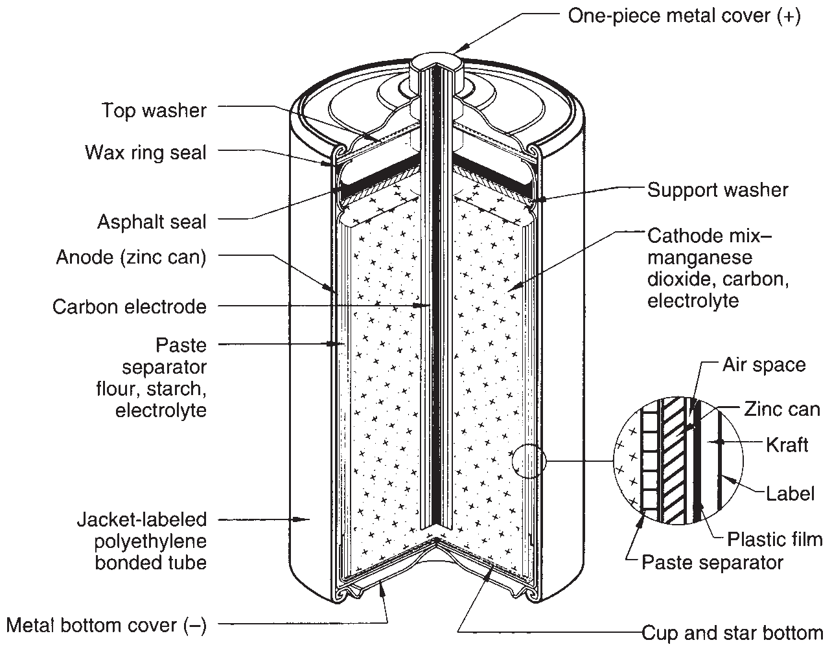

**FIGURE 8.1** Typical cutaway view of cylindrical Leclanche´ battery (‘‘Eveready’’) paste separator, asphalt seals.